IBM Streams 4 introductory hands-on lab

for Quick Start Edition VMware image 4.1.1

April 2016  
Robert Uleman

Contents

Overview 3

About this Lab 3

Lab Structure 4

Lab environment 4

Install the lab files 5

Lab 1 A simple Streams application 6

1.1 Getting started 6

1.2 Starting Streams Studio 7

1.3 Creating a Streams project 8

1.4 The Project Explorer view (optional) 10

1.5 Developing an application in the graphical editor 11

1.6 Running an Application 20

Lab 2 Understanding the flow of data 24

2.1 Building on the previous results 24

2.2 Enhancing the application 24

2.3 Monitoring the application with the Instance Graph 26

2.4 Viewing stream data 29

Lab 3 Enhanced analytics 31

3.1 Building on the previous results 31

3.2 A window-based operator 31

3.3 The Streams Console 35

3.4 The application dashboard 37

3.5 Optional: watching back-pressure develop 38

3.6 Monitoring a job 39

3.7 Visualizing data 40

Lab 4 Modular application design with exported streams 43

4.1 Building on the previous results 43

4.2 Adding a test for unexpected data 43

4.3 Splitting off the ingest module 47

4.4 Adding a live feed 50

4.5 Showing location data on the map 52

4.6 Putting it all together 53

#### Overview

IBM Streams (*Streams*) enables the continuous processing and fast analysis of possibly massive volumes of moving data to speed up business insight and decision making. Streams provides an execution platform for user-developed applications that ingest, filter, analyze, and correlate the information in streaming data.

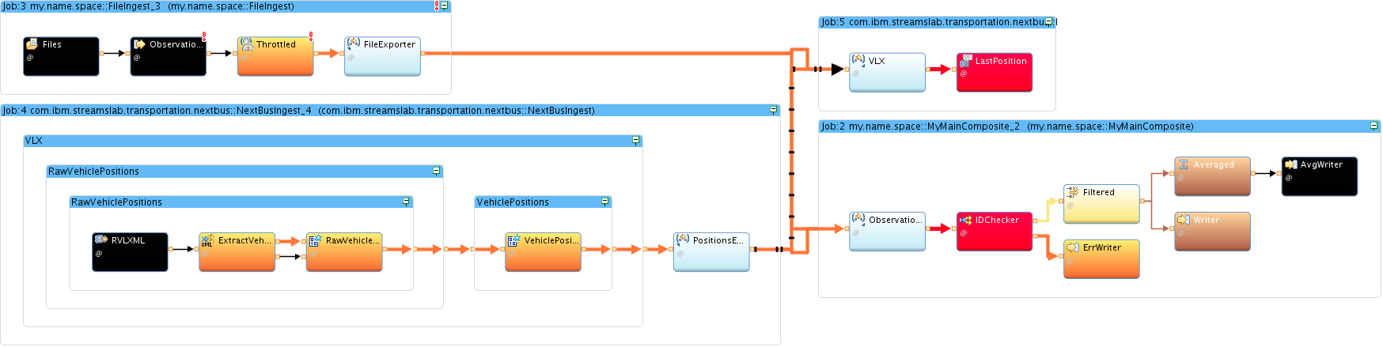 Figure . A Streams application, represented as a graph of connected operators

Table 1 below lists the major components that make up the Streams platform.

Table . Streams major components

|  |  |
| --- | --- |
| Component | Description |
| Streams runtime | A set of processes that work together to let you run stream processing applications on a group of host computers (“resources”) in a cluster. |
| Streams Studio (*Studio*) | An Eclipse-based Integrated Development Environment (IDE) for creating, compiling, running, visualizing, and debugging Streams applications. |
| Streams Console | A web-based graphical user interface for managing and monitoring the runtime environment and applications. |
| Streams Processing Language (SPL) | A declarative and procedural language and framework for writing stream processing applications. |
| Development and management interfaces | APIs for creating building blocks (toolkits) and interfaces for interacting manually and programmatically with the runtime and applications. |

##### About this Lab

The purpose of this lab is to introduce many of the components and features of Streams Studio while developing a small sample application. While the underlying SPL code is always accessible, this lab requires no direct programming and will not dwell on syntax and other features of SPL.

The basis of this lab is a simple example from a *connected-car* automotive scenario: handling vehicle locations and speeds (and other variables).

Through this lab, you will learn:

* The basics of stream computing, the fundamental concepts of Streams, and the Streams runtime environment
* How to use Streams Studio for creating and importing projects, submitting and canceling jobs, and viewing jobs, health, metrics, and data
* How to use the graphical editor to design and enhance a Streams application
* How to use the data visualization capabilities in the Streams Console

##### Lab Structure

The lab is broken into four parts, each part providing the foundation for the next. To ensure

**Part 1** – A simple Streams app. Open Streams Studio; explore its views. Create an SPL application project; create an application graph with three operators; configure the operators. Run the application and verify the results.

**Part 2** – Enhance the app: add the ability to read multiple files from a given directory and slow down the flow so you can watch things happen. Learn about jobs and PEs. Use the Instance Graph to monitor the stream flows and show data.

**Part 3** – Enhance the app: add an operator to compute the average speed every five observations, separately for two cars. Add another operator to check the vehicle ID format and separate records with an unexpected ID structure onto an error stream. Use the Streams Console to visualize results.

**Part 4** – Enhance the app: Use exported application streams to create a modular application. If possible (internet access required), bring in live data. Show the live and simulated location data on a map.

To encourage experimentation and exploration, the lab installation includes prebuilt projects that represent the “correct” result of each part. This way, you can experiment and get yourself in trouble any way you like in any part and still go on to the next part with everything in place, simply by importing one of the provided projects.

|  |  |
| --- | --- |
| sign-info | A word about these lab instructions  The sections in this guide usually begin with a description of what you’re about to learn or accomplish. These are meant to set the stage, but they don’t tell you exactly what to do or how to do it. They are always followed by detailed, numbered, step-by-step instructions. If you’re daring and want to figure it out yourself, of course, go for it; but if you’re wondering what to do next, just keep reading to find the actual steps. |

##### Lab environment

These lab instructions assume that you are using the current [IBM Streams Quick Start Edition](https://www.ibm.com/services/forms/preLogin.do?source=swg-ibmistvi&S_TACT=M161075W) (QSE) VMware Image. The following is already installed on that image:

* Red Hat Enterprise Linux 6.5 (64-bit)
* IBM Streams QSE 4.1.1.0, including Streams Studio

Table . QSE virtual machine information

|  |  |
| --- | --- |
| Parameter | Value |
| Host name | streamsqse (streamsqse.localdomain) |
| User and administrator ID | streamsadmin (logged in automatically) |
| User home directory | /home/streamsadmin |
| User password | passw0rd (password with a zero for the O) |
| root password | passw0rd |
| Streams domain | StreamsDomain (started automatically) |
| Streams instance | StreamsInstance (started automatically) |

The lab workspaces, data files, and additional toolkits need to be installed separately; instructions follow in the next section.

|  |  |
| --- | --- |
| sign-info | If you’re not using the Quick Start Edition VMware image  You can install and run the lab in any other environment with a current Streams installation, but some things may look different, depending on how closely your environment matches the description above. User ID and home, domain and instance names, and operating system version may be different, and you will not have the same desktop with its convenient launchers. |

##### Install the lab files

After opening up the QSE VMware image, you need to install the lab projects, data files, and toolkits.

1. Open the Firefox browser (in the VMware image) to the Introductory Streams Lab page on Streamsdev: <https://developer.ibm.com/streamsdev/docs/streams-lab-introduction/>.
2. Follow the link to the current version: 4.1.1.
3. Follow the instructions on that page.

# A simple Streams application

In this part, you will develop an application for a simple scenario: read vehicle location, speed, and other sensor data from a file, look for observations of a specific few vehicles, and write the selected observations to another file.

After familiarizing yourself with Streams Studio, you will create an SPL application project, build an application graph with three operators, configure the operators, run the application, and verify the results.

## Getting started

If you have successfully installed the lab files, your desktop will look like **Error! Reference source not found.**, **Error! Reference source not found.**:

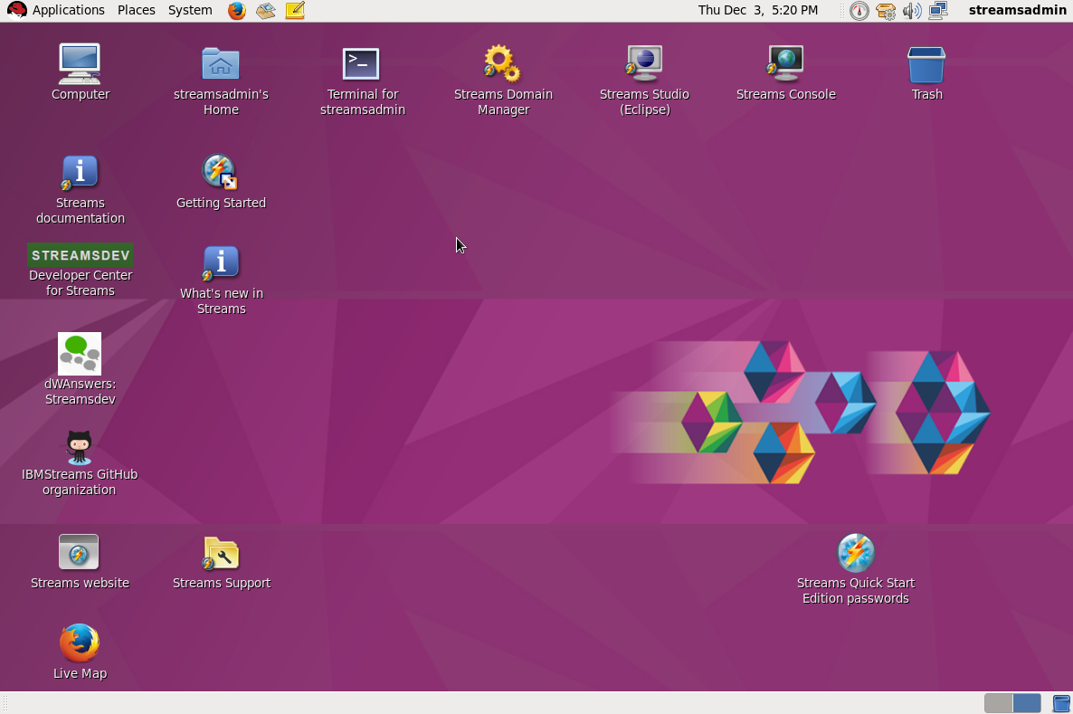

Figure . Desktop view after installing the lab files

###### Background information

* In Streams, a *domain* is a logical grouping of resources in a network for the purpose of common management and administration. The domain is managed by a small number of Linux services (*daemons*) for tasks such as authentication and authorization, auditing, supporting the Streams Console, etc.
* A domain can contain one or more Streams *instances* that share the domain’s security model. An instance provides the runtime environment that you can submit applications to. It consists of a small number of additional services; this includes a resource manager, an application manager, and a scheduler, among others.

|  |  |
| --- | --- |
| sign-info | Your domain and instance are ready to run your applications  In the QSE VM, a domain (StreamsDomain) and instance (StreamsInstance) have already been created and automatically started. This means that everything you need to run and test your applications is already prepared for you; the lab does not explore the creation and administration of domains and instances. |

## Starting Streams Studio

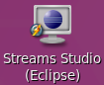It is time to start Studio, explore some of its features, and create your first application.

1. Double-click the **Streams Studio** desktop launcher.
2. In the **Workspace Launcher**, accept the prepopulated Workspace /home/streamsadmin/workspace and click **OK**.

The Eclipse-based Studio IDE opens and settles down after a few progress dialogs disappear.

1. The Eclipse window is divided into multiple *views* or subwindows, some of which contain multiple *tabs*. Make yourself comfortable by exploring.
   1. On the left is a view with two tabs: **Project Explorer** shows project contents and details; **Streams Explorer** shows domain and instance info, including running jobs, if any.
   2. The center view, now empty, is reserved for editors (for code and application graphs).
   3. On the right is an **Outline** view (empty until you open an SPL source file in an editor).
   4. The **Console** tab in the bottom view shows progress messages; the **Properties** tab in the same view will come up later. This lab does not use the Problems tab.
   5. The entire arrangement is called a *perspective* in Eclipse; this is the **InfoSphere** **Streams perspective**.
2. 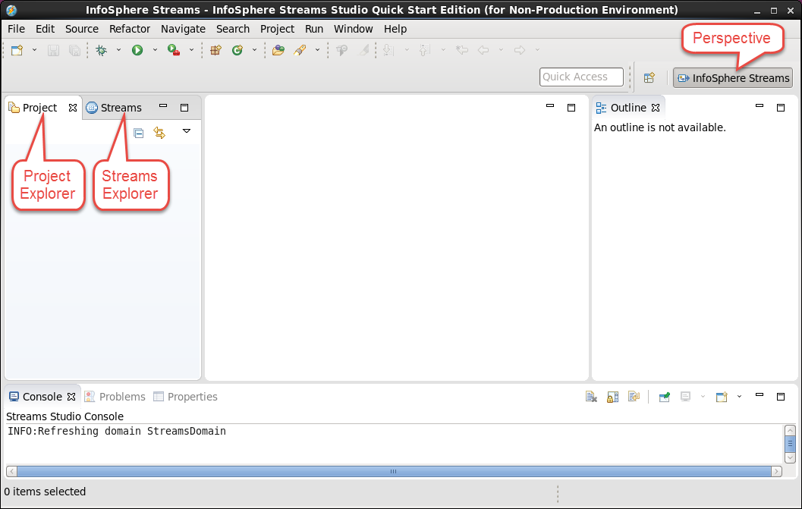

|  |  |
| --- | --- |
| sign-info | InfoSphere?  Well, yes. Originally, Streams was called IBM **InfoSphere** Streams. Beginning with release 4.1, we dropped that extra brand name, but you will still find it in several places in the product, such as in installation directories and pretty much all over Streams Studio. |

## Creating a Streams project

You’re ready to start building your application. First you’ll create a Streams project (a collection of files in a directory tree in the Eclipse workspace) and then an application in that project.

1. In the top Studio menu, choose **File > New > Project…**.   
   Alternatively, right-click in the **Project Explorer** and choose **New > Project…**.
2. In the **New Project** dialog, expand **InfoSphere Streams Studio** and select **SPL Application Project**; click **Next >**.
3. 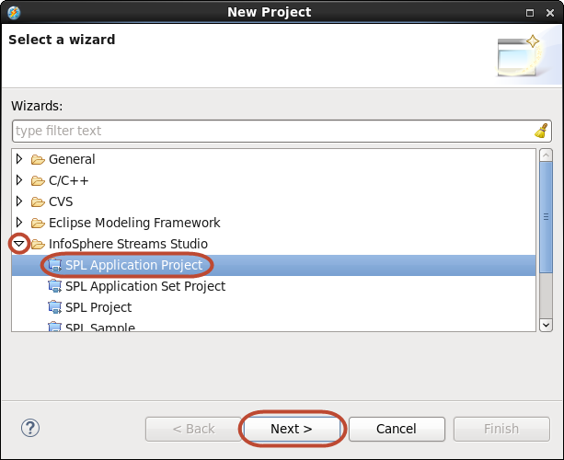

The **New SPL Application Project** wizard takes care of a number of steps in one pass: creating a project, a namespace, an SPL source file, and a main composite.

|  |  |
| --- | --- |
| sign-info | Main composite  In Streams ”main composite” is synonymous with “application”. Usually, each main composite lives in its own source file (of the same name), but this is not required. This lab does not explore the nature of composite operators or what distinguishes a main composite from any other composite. |

1. In the **New SPL Application Project** wizard, enter

Project name: MyProject  
Namespace: my.name.space  
Main Composite Name: MyMainComposite

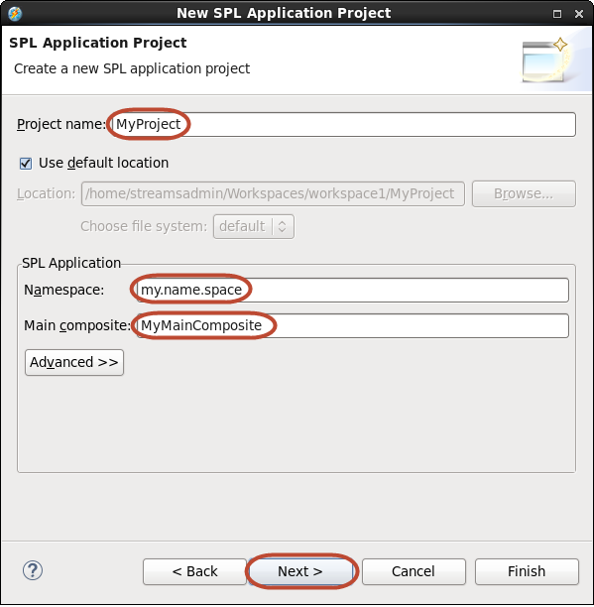Click **Next >**.

1. On the **SPL Project Configuration** panel, change the **Toolkit name** to MyToolkit; uncheck **Toolkit Locations** in the **Dependencies** field. Leave the rest unchanged. Click **Finish**.
2. 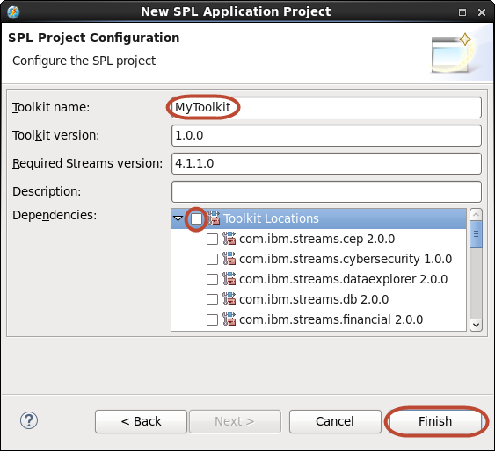

|  |  |
| --- | --- |
| sign-info | Project dependencies  In the **Dependencies** field you can signal that an application requires operators or other resources from one or more toolkits—a key aspect of the extensibility that makes Streams such a flexible and powerful platform. For now, you will only use building blocks from the built-in Standard Toolkit. |

The new project shows up in the **Project Explorer** view, on the left.

The code module **MyMainComposite.spl** opens in the graphical editor, with an empty composite **MyMainComposite** in the canvas.

|  |  |
| --- | --- |
| sign-info | Hint  If you want to give the editor more space, close the **Outline** view and collapse the **Layers** and **Color Schemes** palettes (this lab does not use them). |

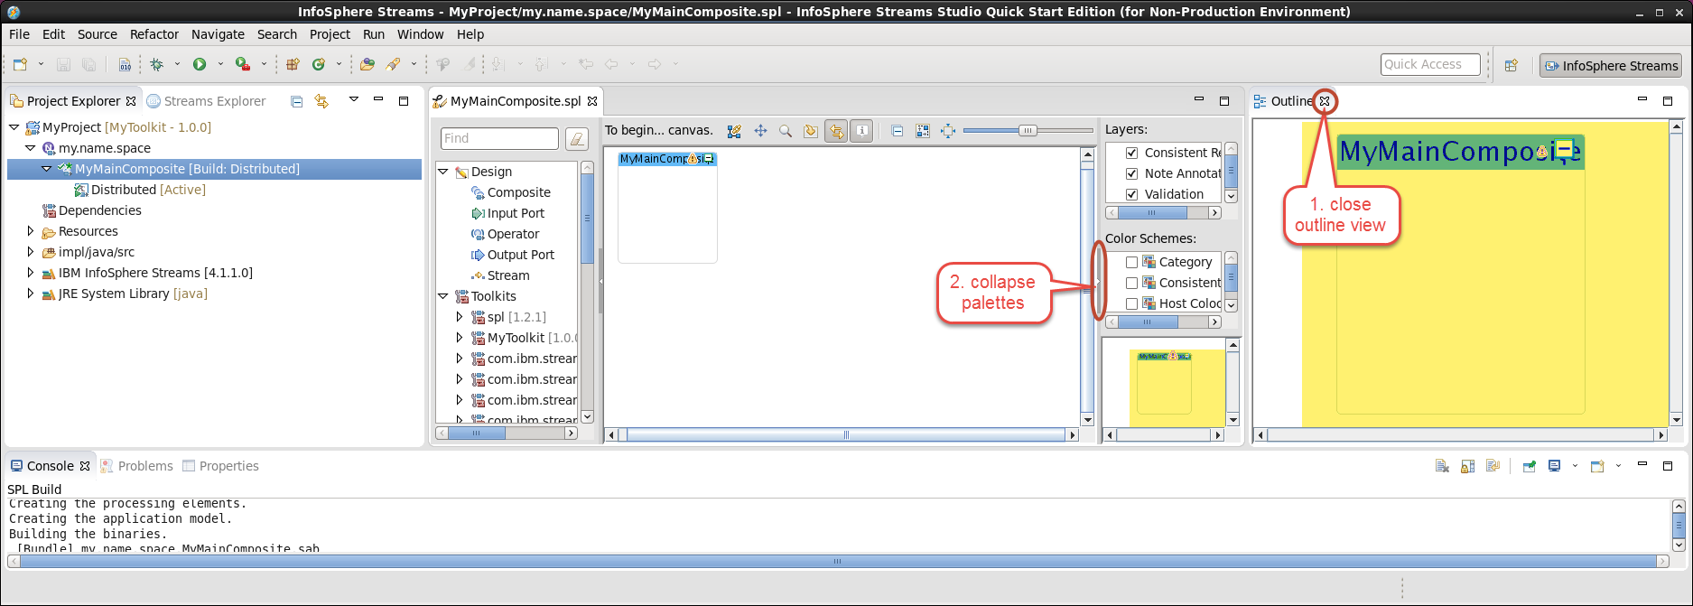

## The Project Explorer view (optional)

Let’s take a quick tour of one of the supporting Studio views. The **Project Explorer** shows both an object-based and a file-based view of all the projects in the workspace.

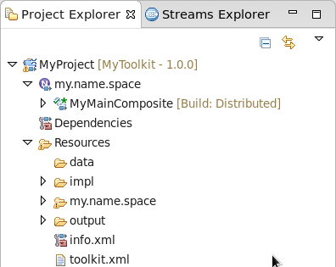

1. In **Project Explorer**, expand **MyProject** by clicking the *twisty* (triangle) on the left.
2. The next level shows namespaces (only one, in this case), a dependencies entry, and resources (directories and files).
3. Under **MyProject**, expand the namespace **my.name.space**.
4. The next level shows main composites; other objects, such as types and functions, if you had any, would appear there as well.
5. Under **my.name.space**, expand the main composite **MyMainComposite**.
6. The next level shows build configurations; here, there is only one, **Distributed**, created by default. You can create multiple builds, for debug, for standalone execution, and other variations.
7. Expand **Resources**.
8. The next level shows a number of directories, as well as two XML files containing descriptions of the current application or toolkit. (In Streams, toolkit and application are the same in terms of project organization and metadata.) The only directory you will use in this lab is the data directory: by default, build configurations in Streams Studio specify this as the root for any relative path names (paths that do not begin with “/”) for input and output data files.

|  |  |
| --- | --- |
| sign-info | Default data directory  Beginning with version 4.0, Streams applications do not have a default data directory unless you explicitly set one in the build specification. Here, we are simply taking advantage of a feature of Streams Studio, which will provide that specification by default. It works, because we only have a single host.  Because Streams is a distributed platform that does not require a shared file system, you have to be careful when specifying file paths. A process accessing a file must run on a host that can reach it; in general this means specifying absolute paths and constraining where a particular process can run; using relative paths and a default data directory makes the application less portable. |

## Developing an application in the graphical editor

You are now ready to begin building the simple application. The high-level requirements are:

* Read vehicle location data from a file
* Filter vehicle location data by vehicle ID
* Write filtered vehicle location data to a file

More detailed instructions (simply read these; step-by-step instructions follow):

* Design the application graph in the graphical editor
* Use three operators (an operator is the basic building block of an application graph): one each to read a file (**FileSource**), write a file (**FileSink**), and perform the filtering (**Filter**)
* Take it step by step:
  + Define a new type for location data, to serve as the **schema**, or **stream type**, of several streams
    - A schema defines the *type*, or structure, of each packet of data, or *tuple*, flowing on the stream. The tuple type is a list of named *attributes* and their types. Think of a tuple as the Streams analogue of a row in a table or a record in a file, and of its attributes as the analogue of columns or fields.
  + Drop the required operators into the editor
  + Make the required stream connections to “wire up” the graph
  + Define the schema of the streams in the graph
  + Specify the parameters and other details of the individual operators

While this lab is only intended as introductory exploration, leaving out any considerations of SPL syntax and coding best practices, one such practice is worth illustrating: rather than defining the schema (stream type) of each stream separately in the declaration of each stream, create a type ahead of time, so that each stream can simply refer to that type. This eliminates code duplication and improves consistency and maintainability.

Therefore, you’ll begin by creating a type, **LocationType**, for the vehicle location data that will be the main kind of tuple flowing through the application, using the specifications in Table 3 on page 12.

Table . Stream type for vehicle location data

|  |  |  |
| --- | --- | --- |
| Name | Type | Comment |
| id | rstring | Vehicle ID (an *rstring* uses “raw” 8-bit characters) |
| time | int64 | Observation timestamp  (milliseconds since 00:00:00 on January 1, 1970) |
| latitude | float64 | Latitude (degrees) |
| longitude | float64 | Longitude (degrees) |
| speed | float64 | Vehicle speed (km/h) |
| heading | float64 | Direction of travel (degrees, clockwise from north) |

1. In the graphical editor for **MyMainComposite.spl**, right-click anywhere on the canvas, outside the main composite (MyMainComposite), and choose **Edit**.
2. This brings up a **Properties** view, which floats above all the other views. Make sure it looks as below, with the three tabs for General, Uses, and Types; if not, dismiss it and right-click again in the graphical editor, outside the main composite.
3. 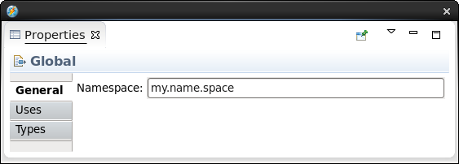
4. In the **Properties** view, click the **Types** tab.   
   Select the field under **Name**, which says Add new type….   
   Key in LocationType; press **Enter**.   
   Select the field in the **Name** column below **LocationType**, which says Add attribute….   
   Key in id; press **Tab** to go to the Type column.   
   Key in rstring; Press **Tab** to go to the next name field.

|  |  |
| --- | --- |
| sign-info | Content assist  In the **Type** column, use **Ctrl+Space** to get a list of available types. Begin typing (for example, “r” for rstring) to narrow down the list; when the type you want is selected, press **Enter** to assign it to the field. This reduces keyboard effort as well as the probability of errors. |

1. Continue typing and using **Tab** to jump to the next field to enter the attribute names and types listed in Table 3, above.
2. 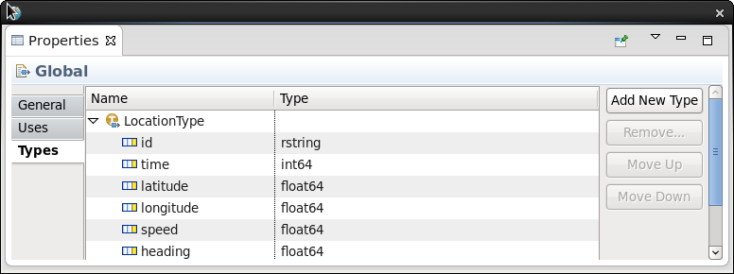

The tuple type **LocationType** is now available for use as a stream type in any main composite within the namespace **my.name.space**. You are now ready to construct the application graph, given a few more specifications, which are listed in Table 4, below. Leave the Properties view up.

|  |  |
| --- | --- |
| sign-info | Properties views  An alternative to the floating Properties view, which may obscure other views and get in your way, is the Properties tab in the view at the bottom of the perspective. It shows the same information. |

Table . Other application requirements

|  |  |
| --- | --- |
| Parameter | Value |
| Input file | /home/streamsadmin/data/all.cars |
| Output file | filtered.cars |
| File format | CSV (both input and output) Do not quote strings on output |
| Filter condition | vehicle ID is “C101” or “C133” |
| Stream names | Observations (before filter) Filtered (after filter) |

With this information, you can create the entire application. You will use the graphical editor. There will be no SPL coding in this lab.

|  |  |
| --- | --- |
| sign-info | Want to see code?  If you do want to see SPL code for what you are creating, just right-click anywhere in the graphical editor and choose **Open with SPL Editor**. Explaining what you see there is beyond the scope of this lab. |

To drop the operators you want into the editor, you need to find them in the palette: this is the panel to the left of the canvas, showing various elements under the headings Design, Toolkits, Exported Streams, Governance Catalogs, and Current Graph. You are looking for three specific operators: **FileSource**, **FileSink**, and **Filter**. You can filter the palette contents and quickly get the ones you want.

First, you will reduce clutter in the palette. Initially, the list of toolkits is long, because it shows all toolkits that Streams Studio knows about; in your preconfigured lab workspace, that means all toolkits installed with Streams. For now, you will not use any of those toolkits (and you have not declared any dependencies), so it is not helpful to have them in the palette.

1. In the graphical editor for **MyMainComposite.spl**, right-click on **Toolkits** in the palette; in the context menu, uncheck **Show All Toolkits**.
2. 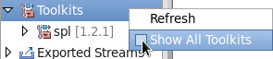
3. In the graphical editor for **MyMainComposite.spl**, go to the palette filter field (showing Find), and type fil. As it happens, this narrows the palette down to a list that includes the three operators you need. Select each one with a twisty in front of it in turn and drag it into the **MyMainComposite** main composite (make sure the green handles appear before you let go). The editor names the operators: **FileSink_1**, **FileSource_2**, and **Filter_3**.
4. 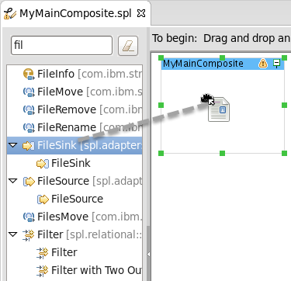

|  |  |
| --- | --- |
| sign-caution | Note  Make sure that the main composite MyMainComposite, and not one of the previously added operators, is highlighted when you drop the next operator. If a **Confirm Overwrite** dialog comes up, simply click **No** and try again. |
| sign-caution | Note  If you drop the operator on the canvas outside the main composite, the editor creates a new composite (called **Comp_1**) and places the operator there. If that happens, simply undo **(Ctrl+Z** or **Edit > Undo Add Composite with Operator**) and try again. |
| sign-info | Operator templates  Some operators appear once in the palette; others (the ones you used) have twisties and expand into one or more subentries. These are **templates**: invocations of the operator with specific settings—for example, a **Filter** operator with a second output port to produce rejected tuples. In this lab, the generic version (with the twisty) is always the right one; don’t use the templates. |
| sign-info | Operator names  The editor generates placeholder names for the operators you drag onto the canvas, consisting of the operator kind (“FileSink”) and a sequence number (“_1”). The sequence number depends on the order in which the operators are added to the graph, and yours may not match this document. You can safely ignore that: it does not affect anything in the application, and in any case you will change the generated names later, to match the role each operator plays. |
| sign-info | Organize layout and maximize in view  To organize the layout, click the  **Layout** button in the editor’s toolbar; to zoom in and use all of the space in the graphical editor canvas, click the  **Fit to Content** button. The **slider** in the toolbar lets you manually control the zoom level. |

|  |  |  |  |
| --- | --- | --- | --- |
|  |  | **Layout 🡺** |  |

1. Add a stream connecting **FileSource_2**’s output to **Filter_3**’s input.
2. Output ports are shown as little yellow boxes on the right side of an operator; input ports on the left. To create a stream, click on an output port and start dragging. The cursor changes to a **+** cross, dragging a line from the output port. Release the mouse button as you drag, and click on the input port of another operator (it turns green when you hover over it) to complete the link. The two ports are now connected by a dashed line, indicating that there is a stream but its type is not yet defined.
3. Add another stream, from **Filter_3** to **FileSink_1**. Click  **Layout** and  **Fit to Content** to organize the graph.

|  |  |  |  |
| --- | --- | --- | --- |
|  | | **Layout 🡺** |  |
| sign-info | Hover popups  By default, hovering over an operator in the graphical editor brings up a popup showing the SPL code behind that operator. As you build and lay out the graph, these popups may get in the way. Click the **Toggle hover** toolbar button to turn off these popups. | | |

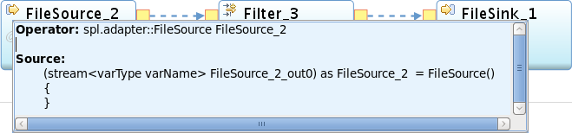 

You now have the complete graph, but none of the details have been specified.

1. Save your work: use **Ctrl+S** or the  **Save** toolbar button, or **File > Save** in the menu.

The main composite as well as the three operators it contains now have  error indicators. This is expected, as the code so far contains only placeholders for the parameters and stream types, and those placeholders are not valid entries.

1. To assign a name and type to a stream, select the stream (dashed arrow) connecting **FileSource_2** and **Filter_3**. (Sometimes you need to try a few times before the cursor catches the stream, instead of selecting the enclosing main composite.)
2. 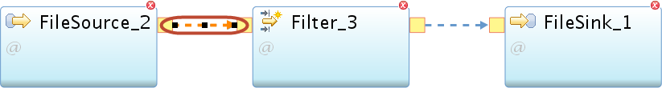
3. The **Properties** view, which you used earlier to create LocationType, now shows **Stream** properties. Reposition and resize the view if necessary so it doesn’t obscure the graph you’re editing. (If you closed the Properties view, double-click the stream toreopen it.)
4. Descriptive stream names are preferable to the placeholder names generated by the editor.
   1. In the **Properties** view (**General** tab), click **Rename…**.
   2. 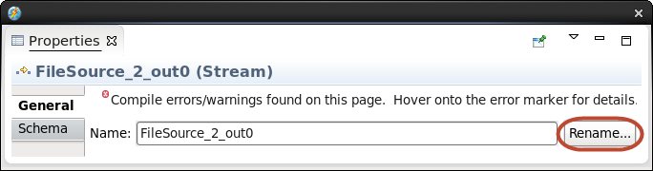
   3. In the **Rename** dialog, under **Specify a new name:** type Observations, and click **OK**.

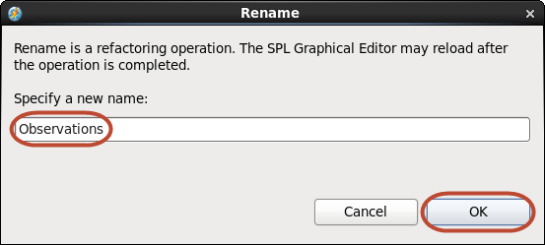

|  |  |
| --- | --- |
| sign-info | Refactoring  Why do you have to click a button and bring up a new dialog to rename a stream or an operator? Why not just type away in the field showing the name? Because changing a name involves a *refactoring* process, meaning that all references to that name must be found and changed too. Streams Studio needs a signal to know when to kick off this process; in this case, you provide that signal by clicking **OK**. |

1. Specify the stream schema. You can do that in the Properties view, but since you have created a type for this, you can also just drag and drop it in the graphical editor, like any other object.
2. In the graphical editor, clear the palette filter by clicking the eraser button  next to where you typed fil earlier; this makes all the objects visible again. Under **Current Graph**, expand **Schemas**. This shows the **LocationType** type, along with the names of the two streams in the graph. Select **LocationType** and drag it into the graph; drop it onto the **Observations** stream (the one between **FileSource_2** and **Filter_3**). Make sure the stream’s selection handles turn green as you hover before you let go, as shown below.
3. 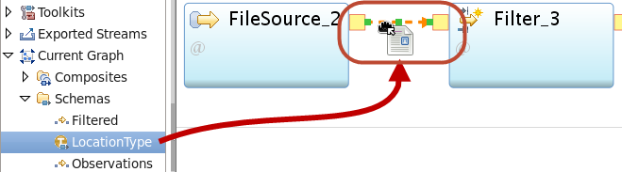
4. If you open the Properties view to the Schema tab, it now shows a Type of **LocationType**, and **<extends>** as a placeholder under Name. This indicates that the stream type does not contain some named attribute of type LocationType, but instead inherits the entire schema with its attribute names and types.
5. Using the same drag and drop technique, assign the **LocationType** type to the other stream, between **Filter_3** and **FileSink_1**. Select that stream so its properties show in the **Properties** view.
6. In the **Properties** view, **General** tab, rename the stream to Filtered. (Click **Rename…**, etc.)

There is still an error indicator on **FileSink_1** and, because of that, on the main composite, too. This is expected, because you have not yet told the **FileSink** operator what file to write. You also need to provide details for the other operators.

1. In the graphical editor, select **FileSink_1**. In the **Properties** view, click the **Param** tab. This shows one mandatory parameter, **file**, with a placeholder value of parameterValue (not a valid value, hence the error marker). Click on the field that says parameterValue and type "filtered.cars" (with the double quotes). Press **Enter**.
2. Note that this is a relative path (it doesn’t start with “/”), so this file will go in the **data** subdirectory of the current project, as specified by default for this application.
3. You need two more parameters. Click **Add…**; in the **Select parameters** dialog, check **format** and **quoteStrings** (you may have to scroll down to find it); click **OK**. For the value of **format**, enter csv (no quotes: this is an **enumerated** value). For the value of **quoteString**, enter false (no quotes: this is a **boolean** value).
4. 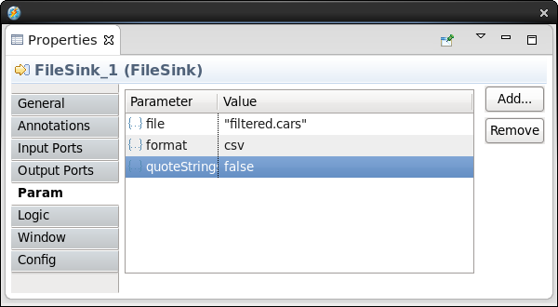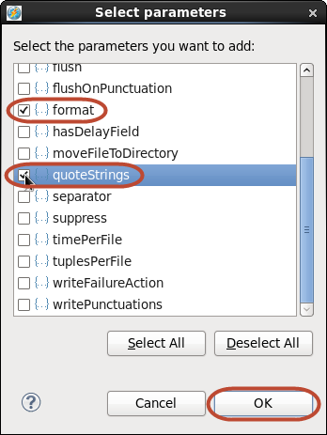
5. The **FileSource** operator needs to know what file to read. In the graphical editor, select the **FileSource_2** operator. In the **Properties** view (**Param** tab), click **Add…**; in the **Select parameters** dialog, select **file** and **format**, and click **OK**. In the value for **file**, enter "/home/streamsadmin/data/all.cars" (with quotes and exactly as shown here, all lowercase); for **format**, enter csv.
6. You have to tell the **Filter** operator what to filter on; without a filter condition, it will simply copy every input tuple to the output. In the graphical editor, select **Filter_3**. In the **Properties** view (**Param** tab), click **Add…**; in the **Select parameters** dialog, select **filter** and click **OK**.
7. In the value field, enter the boolean expression id in ["C101","C133"] to indicate that only tuples for which that expression evaluates to true should be passed along to the output. (The expression with the key word in followed by a list evaluates to true only if an element of the list matches the item on the left.)
8. 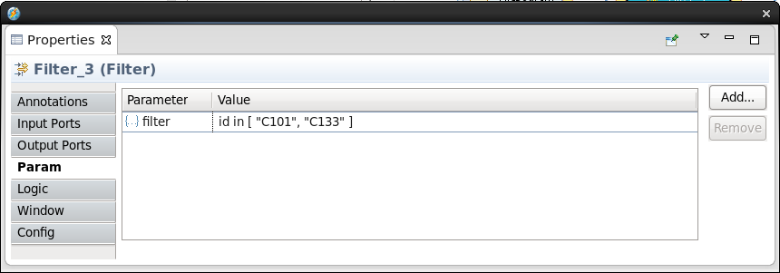
9. **Save**. The error markers disappear: you have a valid application.
10. There are just a few more things to clean up.
    1. Select the **FileSink** operator again. Go back to the **General** tab in the **Properties** view; rename the operator in the same way you renamed the two streams earlier; call it Writer.
    2. Select the **FileSource** operator and rename it. This time, simply keep the name blank. Observe how the Identifier changes to Observations, the name of the output stream.
    3. Also rename the **Filter** operator by blanking out the alias. In the graph it will show up as Filtered (the name of the output stream).
11. **Save**. Dismiss the floating Properties view.

|  |  |
| --- | --- |
| sign-info | Operator identifiers and aliases: confusing?  SPL automatically assigns names (Identifiers) to operators by using the name(s) of the output stream(s). It also provides for aliases to use as identifiers instead, giving the developer more control. The graphical editor automatically assigns a generated alias to every operator; but in case of a single output stream, using the stream name is usually fine, so we prefer to omit the alias. For multiple output streams, it’s a good idea to provide a more descriptive alias. When there is no output stream (as for the FileSink), an alias is mandatory. |

The Properties view may have been obscuring this, but each time you saved the graph, a *build* was started to compile the application; the progress messages are shown in the **Console view** (in the **SPL Build** console). If you scroll back (you may also want to enlarge or maximize the Console view), you will see some builds that terminated on errors, with messages in red. The last build should have completed without any errors.

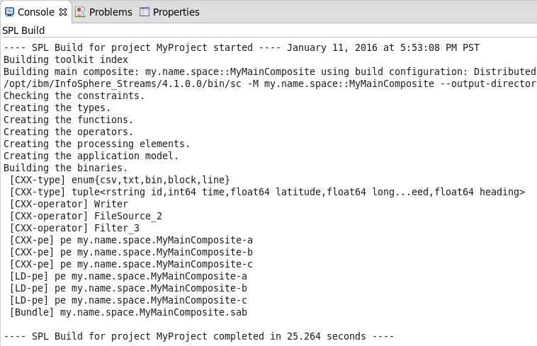

## Running an Application

You are now ready to run this program or, in Streams Studio parlance, launch the build.

1. In the **Project Explorer**, right-click **MyMainComposite** (expand **MyProject** and **my.name.space** if necessary); choose **Launch…**.
2. 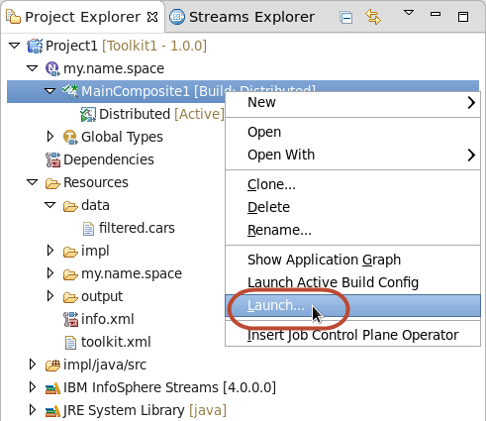
3. In the **Edit Configuration** dialog, click **Apply**, and then **Continue**.

The **Streams** **Launch** progress dialog appears briefly. To see what happened, switch consoles, from the SPL Build to the Streams Studio Console.

1. In the Console view, click the **Display Selected Console** button (way over to the right) to switch consoles.   
   
2. The **Streams Studio** **Console** shows that job number 0 was submitted to the instance called **StreamsInstance** in the domain **StreamsDomain**.

|  |  |
| --- | --- |
| sign-info | Launch configuration  There are many options that can be set or changed at the time you launch an application; for now, ignore all that. |

Since nothing else seems to have happened, you need to look for some effect of what you’ve done. First, you’ll view the job running in the instance; then you’ll inspect the results.

1. Switch to the **Streams Explorer** (the second tab in the view on the left, behind the **Project Explorer**). Expand the **Streams Domains** folder, the one domain named **StreamsDomain**, and the **Resources** and **Instances** folders under that:
2. 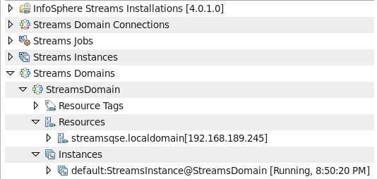

The Resources folder refers to the machines available to the domain; of course, in this virtual machine there is only one. Resource tags let you dedicate different hosts to different purposes, such as running runtime services or application processes. In this single-resource environment, this is not relevant.

|  |  |
| --- | --- |
| sign-info | Streams jobs and instances  The Streams Jobs and Streams Instances folders simply repeat, for convenience, information from the Instances folders under the listed domains, but they lack further drill-down information. |

You know you have one instance, **StreamsInstance**, in the domain StreamsDomain; the entry tells you that it is the **default** instance (where launched applications will run unless otherwise specified), that it is **Running**, and its current wall clock time. (You may have to widen the view to see the status.)

1. Expand **default:StreamsInstance@StreamsDomain**. This shows a number of elements, but the only one you’re interested in for now is the last one: **0:my.name.space::MyMainComposite_0** is the job you have just submitted (a running application is called a job), and its status is **Healthy**. There is much information here about a job and its constituent operators and Processing Elements (PEs), but you are going to explore it graphically instead.

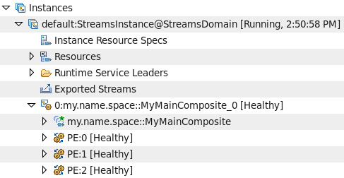

|  |  |
| --- | --- |
| sign-info | What if my job is not healthy?  If you are in an instructor-led lab, ask the instructor to help you. Otherwise, you have to diagnose the problem yourself. The most likely culprit is a mistake in the FileSource’s **file** parameter, which would not be caught by the compiler but would cause a file-not-found exception at runtime. More elaborate debugging, involving trace files and other diagnostics, is beyond the scope of this lab. |

1. Right-click on **default:StreamsInstance@StreamsDomain**; choose **Show Instance Graph**.

A new view opens up in the bottom panel, showing a graph similar to that in the graphical editor; but this one shows, live, what is actually running in the instance. If you launch multiple applications (or multiple copies of the same application) you will see them all. And it lets us inspect how data is flowing, whether there are any runtime problems, etc.

1. If necessary, expand or maximize the **Instance Graph** view; click  **Fit to Content** in the view’s toolbar.
2. 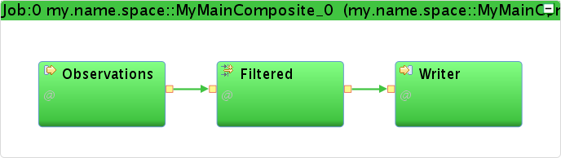

Figure . Finished and running application. All PEs are healthy, so the job is, too.

There is a lot more to the Instance Graph; you will explore it further in the next part.

1. Hover over **Filtered**; you get current information about data flows and other metrics. Among other things, it will tell you that the input received 1902 tuples, and the output sent 95 tuples. This seems reasonable, given that the output should be only a subset of the input. But it also says that the current tuple rate on both input and output is **0/sec**, so no data is currently flowing. Why? Because it has read all the data in the all.cars file, and there will never be any more data.

|  |  |
| --- | --- |
| sign-info | Streams jobs run forever  The input data is exhausted but the job is still running. This is always true for a Streams application running in an instance (*distributed* applications): a job can only be canceled by manual (or scripted) intervention. In principle, a stream is infinite, even though in some cases (like when reading a file) this may not be quite true. |

1. To inspect the results, you must look at the input and output data.
   1. In the top menu, choose **File > Open File...**
   2. In the **Open File** dialog, browse to **streamsadmin/data/all.cars** and click **OK**.
2. Studio opens the file in an editor view; it shows location observations for multiple vehicle IDs: C127, C128, etc.

1. In the **Project Explorer** (the first tab in the view on the left), expand **Resources**; there should be a file under **data**, but there is no twisty in front of the directory. To update the view, right-click **data** and choose **Refresh**. The twisty appears; expand it, and double-click on **filtered.cars**. This file contains coordinates, speeds, and headings only for vehicles C101 and C133.
2. 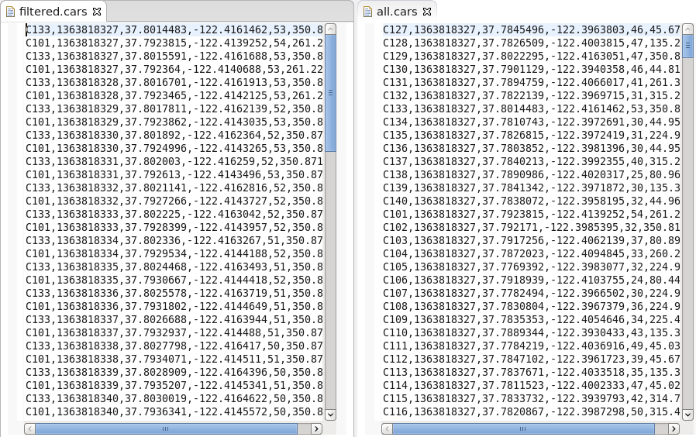

|  |  |
| --- | --- |
| sign-info | Show files side by side  You can show two editors side by side by dragging the tab of one of them to the right edge of the editor view. As you drag, green outlines appear, which arrange themselves side by side as you approach the right edge. To undo, drag the tab back to a position among the other tabs, or close it. |

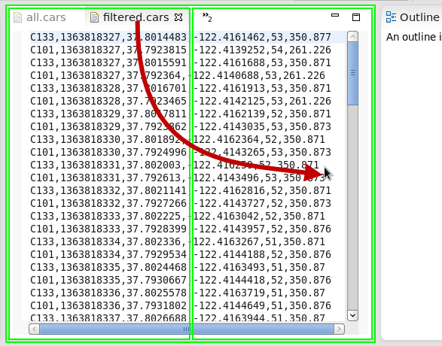

# Understanding the flow of data

In this part, you will further develop the vehicle data filtering application and get a more detailed understanding of the data flow and the facilities in Studio for monitoring and examining the running application. To make this easier, you will make two enhancements that let you see what is happening before the data runs out: you will slow the flow down (left to its own devices, Streams is just too fast) and you’ll make it possible to read multiple files. This is a general design pattern for development and debugging.

## Building on the previous results

|  |  |
| --- | --- |
| sign-caution | This section is optional  If you are confident that your results from the previous part are correct, you can continue working with them and skip this section. |

To continue with this part even if you did not successfully complete the previous part, import a Streams project that has been prepared for you, containing the expected results of Part 1.

1. In the Project Explorer, right-click on the current project (MyProject) and choose **Close Project**.
2. This gets it out of the way for builds or name conflicts, without deleting any files.
3. In the top Eclipse menu, choose **File > Import…**.
4. In the Import dialog, select **InfoSphere Streams Studio > SPL Project**; click **Next >**.
5. Click **Browse…**; in the file browser, expand **My Home**, scroll down, and select **Labs**. Click **OK**.
6. Select (check the box) **MyProject1** and click **Finish**.
7. This kicks off a build, but there is no need to wait until it finishes.
8. In the Project Explorer, expand **MyProject1** and then **my.name.space**.
9. Double-click **MyMainComposite** to open it in the graphical editor.
10. In the editor palette, right-click on **Toolkits**; in the context menu, uncheck **Show All Toolkits**.

## Enhancing the application

Two new operators are needed to make your application easier to monitor and debug. The **Throttle** operator copies tuples from input to output at a specified rate rather than as fast as possible. The **DirectoryScan** operator periodically scans a given directory; for each new file that satisfies optional criteria, it sends out a tuple that contains the file’s full path.

Instead of using the palette’s filter field to quickly pick up the operators you want, let’s browse the full palette to achieve the same result.

1. In the graphical editor’s palette, expand **spl** (under **Toolkits**), and then **spl.adapter**. Drag **DirectoryScan** into the main composite. The editor names the operator **DirectoryScan_4**.
2. Scroll down in the palette and expand **spl.utility**; scroll down further and find **Throttle**. Drag and drop it onto the stream **Observations**, exactly as you did with the **LocationType** schema in step __11. on page 17. (Make sure the stream is highlighted by green handles before you let go.)
3. The operator will be called **Throttle_5**. The editor automatically connects the **Observations** stream to its input port and creates a new stream, with the same schema as Observations, from its output port to the input of **Filtered**. There is no need to adjust the schema of this new stream: The **Throttle** operator merely controls the rate at which tuples flow, without changing their contents.
4. To straighten out the graph, click  **Layout** and  **Fit to Content**.
5. Rename the new stream to Throttled. Rename the operator (to Throttled) by blanking out its alias. (That’s in the **General** tab of the **Properties** view; review Part 1 if you forgot how to get there.)
6. Drag a stream from the output of **DirectoryScan_4** to the input of **Observations**.

|  |  |
| --- | --- |
| sign-info | Optional input ports  The **FileSource** operator can have an input port, but it is optional. In the original graph you did not use it, so there is no yellow box on the left. But while dragging a stream from another operator’s output port, the optional input port is indicated by a lightly outlined, unfilled box, and you can connect the stream to it like any other port. |

1. Click  **Layout** and  **Fit to Content**.
2. 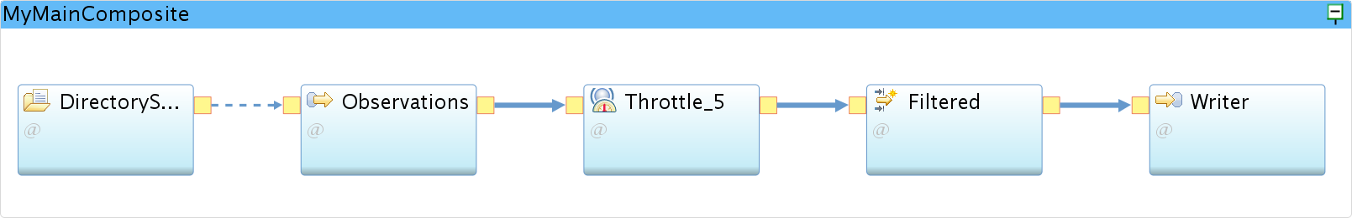

To finish up, you need to define the schema for the stream from the **DirectoryScan**, and tell that operator where to look for files; adjust the configuration of **Observations** (since it now gets its instructions from an input stream rather than a static parameter); and tell the **Throttle** the flow rate you want.

1. The **DirectoryScan** operator’s output port supports only one schema: a single attribute of type rstring, which will hold the full path to the file; you can call that attribute anything you like.
   1. Select the output stream from **DirectoryScan_4**, and rename it to Files.
   2. In the **Schema** tab in the **Properties** view, click on the first **Name** field (placeholder varName) and type file; press **Tab** to move to the next field (placeholder varType).
   3. Enter rstring. Remember to use content assist (**Ctrl+Space**) to reduce typing and avoid errors. Press **Enter**.
2. In the editor, select the **DirectoryScan_4** operator. In the **Properties** view, go to the **Param** tab and set the **directory** parameter to the value "/home/streamsadmin/data". (Remember to include the double quotes.)
3. 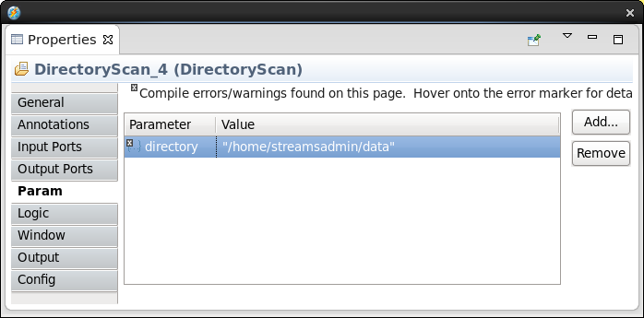
4. Rename the operator (to Files) by blanking out its alias.
5. A **FileSource** operator knows which file(s) to read either from a static parameter (called **file**) or from the tuples coming in on an input stream—but not both. Now that you are getting filenames from a **DirectoryScan** operator, that **file** parameter you used previously is no longer needed; in fact, it’s an error to keep it.
6. Select the **Observations** operator in the editor. In the **Properties** view (**Param** tab), click on the **file** parameter and then click **Remove**.
7. The **Throttle** operator has a mandatory parameter for specifying the desired flow rate; it is a floating-point number with a unit of tuples per second.
8. In the editor, select **Throttled**. In the **Properties** view (**Param** tab), click on the Value field next to the **rate** parameter and enter 40.0. (The decimal point is necessary to indicate a floating-point value).
9. Save. There should be no build errors.

## Monitoring the application with the Instance Graph

The Instance Graph in Studio provides many ways to monitor what your application does and how data flows through a running job. This part of the lab is a matter of exploring those capabilities; the steps here are just hints.

1. Launch the application: In the **Project Explorer**, right-click on the main composite (**MyMainComposite**) and choose **Launch…**. In the **Edit Configuration** dialog, click **Continue** (if you switched workspaces, you may have to click **Apply** first).
2. Maximize the **Instance Graph** view. You now have two running jobs: the one you just launched and the one from the previous exercise. The old one is dormant (it is not getting any data), but leave it running for now.
3. 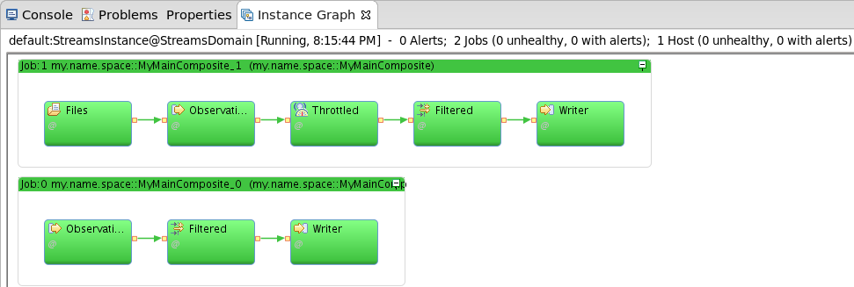

To the right of the Instance Graph, a layout options drop-down menu and two selection panes for **Layers** and **Color Schemes** allow you to control the display. Explore the various options; here are some explanations and suggestions that will help interpret what you see.

The layout options control how the operators in the graph are grouped:

* By **Composite**: This is the default. You see two boxes representing the two main composites—that is, the two applications, and inside each composite the operators that make up the application; three for the old job and five for the new one.
* By **Category**: You can assign categories to your operators to group them any way you want; this is useful when you have a large number of operators. You did not use this facility in this lab, so this option shows all the operators without grouping—though you can still identify the two distinct flows, of course.
* By **PE:** A PE is a **Processing Element**—essentially an operating system process. Operators can be combined (*fused*) into a single PE; this couples them tightly and reduces communication latencies. That is a performance optimization beyond the scope of this lab; you’ve simply used the default of giving each operator its own process. This layout option shows each operator inside a box representing its PE, which in this case does not add much information.
* By **Resource**: Since the virtual machine is only a single resource (host), all operators are shown within the same box representing the resource.

1. For the rest of this exercise, keep the layout set to **Composite**.

In the **Layers** box, only the **Alert** layer is relevant; it should be checked. The other, **Consistent Region**, is beyond the current scope (it has to do with guaranteed tuple delivery); checked or unchecked, it will have no bearing on this lab.

Move on to the **Color Schemes**. Note that they are mutually exclusive (you can only check one at a time), and you cannot interact with the checkboxes on the individual colors under each scheme. It is possible, however, to add new color schemes, and to edit existing ones. The color schemes assign colors to the operators based on their properties (the PE or job they belong to, the resource they run on, etc.) or on metrics—counters maintained by the Streams runtime to monitor diagnostic statistics, which are refreshed periodically and present a real-time view of the instance. This is extremely helpful in identifying problems quickly, especially in a large, complex graph.

1. The default color scheme is **Health**. Expand the twisty for **Health** in the **Color Schemes** pane: green indicates that the operators (actually, their PEs) are healthy, meaning that there are no errors and they are up and running and ready to process data. You may have noticed when launching an application that the operators are red and yellow before they turn green; this reflects the initialization process, during which a PE may be waiting for another to finish loading before a stream connection can be made, for example.
2. Check the **Flow Under 100 [nTuples/s]** color scheme. All operators (most likely) turn black, indicating that no tuples are flowing. This is because it has been more than 45 seconds or so since you launched the application; despite the throttling it finished reading the entire file.

You will need to supply more data. This is easy enough to do by making the same file appear multiple times in the source directory. You can manually do this by making copies of the file in the same directory, using the File Browser or using the command line in a Terminal window.

A better trick is to update the file’s time stamp at regular intervals: each time the DirectoryScan operator sees the file with a new time stamp, it treats it as a whole new file and passes the file path into the FileSource operator. The lab installation provides a desktop launcher that does this at 45-second intervals (about the time it takes the Streams job to read the file), and keeps doing it until you cancel it. This has the effect of simulating an infinite data feed, even though it’s really the same file over and over. You can let this run for the duration of the lab; it does not copy any data and will not fill up the disk.

1. On the desktop, double-click the **Infinite Source** launcher.  (Move or minimize the Studio window to see it.)
2. A Terminal window pops up; leave it up as long as you want data to flow. (It’s OK to minimize it.) To cancel, close the window or type Ctrl+C when the window has the keyboard focus.
3. Maximize the Studio window again and look at the Instance Graph view.
4. After a slight delay (the **DirectoryScan** operator scans every five seconds), the colors change in the new job; the old job stays black, as it is not designed to read more than one file. The colors are mostly yellow (31-40) for **Throttled** and **Filtered**, and brown (1-5) for **Writer**. It makes sense for the rate after the **Filter** operator to be lower, as only a subset of tuples makes it through.
5. 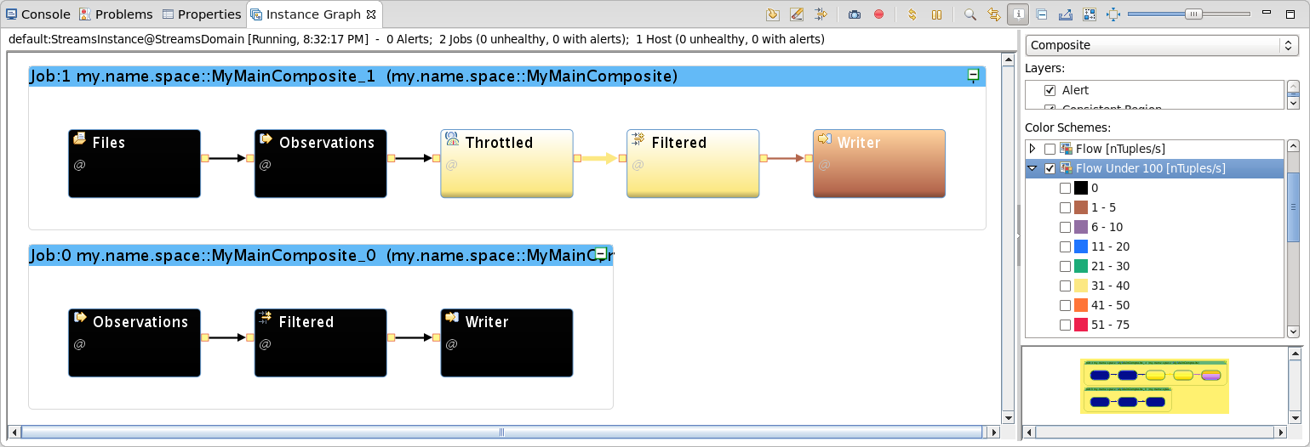
6. Check the **nFinalPunctsSubmitted** color scheme. A Final Punctuation marker is a special message (not a tuple), generated by any operator to indicate that a stream will no longer carry new tuples. This marker travels downstream through the graph; any operator that has received one on every one of its input ports (every operator you’ve used so far has only one input port) is from then on dormant and ready to shut down, and in turn submits a Final Punctuation. Operators without output ports, like the **FileSink**, do not support this metric, so they are not colored by this scheme.
7. Notice that the operators in the old job are now black, indicating that they have submitted a Final Punctuation; this happened when the **FileSource** reached the end of the input file. The operators in the current job are green (no Final Punctuation) because they have not reached the end of the input data, and never will: there is no way to know when another file will appear in the source directory.
8. Now you might as well get rid of the old job; you don’t want it cluttering up your Instance Graph any further. There are at least three options.
   1. If you just want to remove some clutter, simply collapse the main composite by clicking the  **minimize** button in the title bar of the composite.
   2. If you want it to disappear from view altogether but are not ready to cancel the job, just filter it out of the graph display: click the  **Filter graph…** button in the **Instance Graph** view’s toolbar; in the **Instance Graph Filter** dialog, check only the most recent job under **Job ID Filter**, and click **OK**.
   3. To cancel the job completely, right-click anywhere in the main composite and choose **Cancel job**; in the **Confirm** dialog, click **Yes**.
9. Click  **Fit to Content**.

## Viewing stream data

1. While developing, you often want to inspect not just the overall tuple flow, but the actual data. In Part 1 you simply looked at the results file, but you can also see the data in the Instance Graph. This way, you don’t have to add **FileSink**s whenever you want to capture the output of a particular operator. Let’s look at the input to and output from the **Filter** operator to see if it’s working as expected.
2. In the Instance Graph, right-click on the stream **Throttled** (output of the **Throttled** operator, input to **Filtered)**; choose **Show Data**. (If you get an Untrusted Certificate Trust Manager message, select **Permanently accept the certificate** and click **OK**.)
3. In the **Data Visualization** **settings** dialog, verify that the tuple type is what you expect (attributes **id**, **time**, **latitude**, **longitude**, **speed**, and **heading**) and click **OK**. A **Properties** view appears.
4. Repeat the previous step for the stream **Filtered** (between operators **Filtered** and **Writer)**. Move and resize both **Properties** views so you can see the both tables as well as the Instance Graph.
5. Notice that, as expected, the Filtered stream contains only tuples with an **id** value of “C101” or “C133”, whereas the Throttle output contains a greater mix of vehicle IDs.
6. 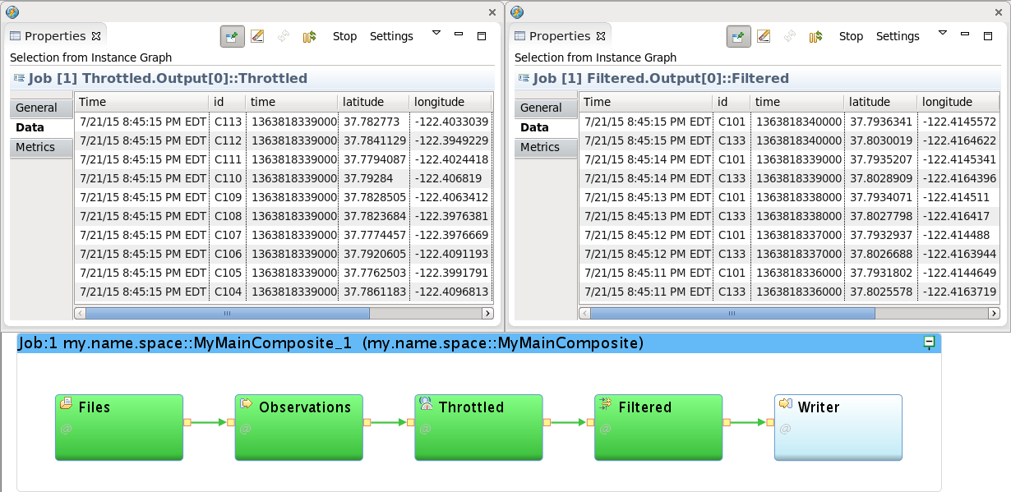
7. When you have seen enough data, dismiss the two floating Properties views.

# Enhanced analytics

In this part, you will enhance the app you’ve built by adding an operator to compute an average speed over every five observations, separately for each vehicle tracked. After that, you will use the Streams Console to visualize results.

So far, the operators you’ve used look at each tuple in isolation; there was no need to keep any history. For many analytical processes, however, it is necessary to remember some history to compute the desired results. In stream computing, there is no such thing as “the entire dataset”, but it is possible to define buffers holding a limited sequence of consecutive tuples—for example, to compute the average over that limited subset of tuples of one or more numeric attributes. Such buffers are called **windows**. In this part, you will use an **Aggregate** operator to compute just such an average.

## Building on the previous results

|  |  |
| --- | --- |
| sign-caution | This section is optional  If you are confident that your results from the previous part are correct, you can continue working with them and skip this section. |

To continue with this part even if you did not successfully complete the previous part, import a Streams project that has been prepared for you, containing the expected results of Part 2.

1. In the Project Explorer, right-click on the current project (MyProject) and choose **Close Project**.
2. This gets it out of the way for builds or name conflicts, without deleting any files.
3. In the top Eclipse menu, choose **File > Import…**.
4. In the Import dialog, select **InfoSphere Streams Studio > SPL Project**; click **Next >**.
5. Click **Browse…**; in the file browser, expand **My Home**, scroll down, and select **Labs**. Click **OK**.
6. Select (check the box) **MyProject2** and click **Finish**.
7. This kicks off a build, but there is no need to wait until it finishes.
8. In the Project Explorer, expand **MyProject2** and then **my.name.space**.
9. Double-click **MyMainComposite** to open it in the graphical editor.
10. In the editor palette, right-click on **Toolkits**; in the context menu, uncheck **Show All Toolkits**.

## A window-based operator

You will compute average speeds over a window, separately for vehicles C101 and C133. Use a *tumbling* window of a fixed number of tuples: each time the window has collected the required number of tuples, the operator computes the result and submits an output tuple, discards the window contents, and is again ready to collect tuples in a now empty window. Window partitioning based on a given attribute means that the operator will allocate a separate buffer for each value of that attribute—in effect, as if you had split the stream by attribute and applied a separate operator to each substream. The specifications are summarized in Table 5, below.

Table . Specifications for window-based aggregation

|  |  |
| --- | --- |
| **Specification** | **Value** |
| Operator type | **Aggregate** |
| Window specification | **Tumbling**, based on tuple **count**, 5 tuples |
| Window partitioning | Yes, based on vehicle ID (**id**) |
| Stream to be aggregated | **Filtered** |
| Output schema | id – rstring  time – int64 avgSpeed – float64 |
| Aggregate computation | Average(speed) |
| Results destination | File: average.speed |

1. Add the two required operators.
   1. In the graphical editor’s palette filter box, type agg; drag an **Aggregate** operator into the main composite. The editor calls it **Aggregate_6**. This is you main analytical operator.
   2. In the palette filter, begin typing filesink until you see the **FileSink** operator; drag one into the main composite: **FileSink_7**. This will let you write the analytical results to a file.
2. Fold the two new operators into the graph by connecting one existing stream and adding another.
   1. Drag a stream from **Filtered** to **Aggregate_6**. This means Aggregate_6 is tapping into the same stream as Writeris already consuming, so the schema is already defined. This is indicated in the editor by a solid arrow.
   2. Drag another stream from **Aggregate_6** to **FileSink_7**. This stream does not yet have a schema, so the arrow is dashed.
3. Click  **Layout** and  **Fit to Content**.
4. 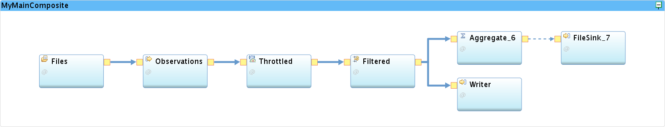
5. Rename the new stream and operators.
   1. Rename the stream to Averaged.
   2. Rename the Aggregate operator to Averaged by blanking out its alias.
   3. Rename the FileSink to AvgWriter.
6. Give the **Averaged** stream (output of the **Aggregate** operator) its own schema. In the **Schema** tab of the **Properties** view for the stream, fill in attribute names and types.
   1. In the first field under **Name,** type id; press **Tab.**
   2. Under **Type**, type rstring; press **Tab** to go to the next name field.
   3. Continue typing (and using **Tab** to jump to the next field) to enter the output schema attribute names and types listed in Table 5 on page 32.
   4. 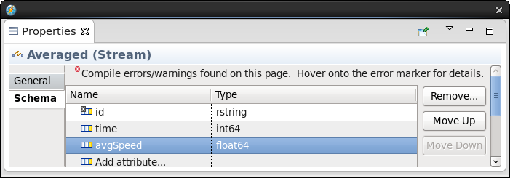
7. Tell the **Aggregate** operator what to do.
   1. Select the **Averaged** operator; in the Properties view, go to the **Window** tab. A placeholder window specification is already filled in; you only need to edit it slightly.
      1. Click **Edit…**;
      2. in the **Add** **Window Mode…** dialog, keep **Tumbling Window** selected;
      3. set **Eviction policy** **value** to 5;
      4. check **Partitioned** (leave **Eviction policy** blank); and
      5. click **OK**.
   2. 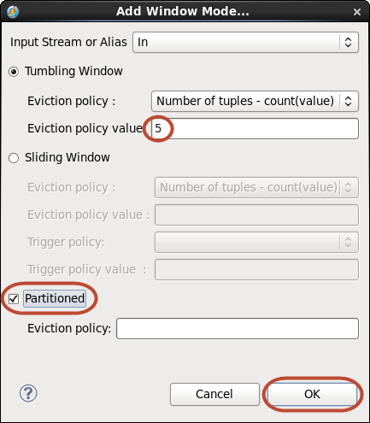
   3. Configure the window as partitioned on vehicle ID (the id attribute).
      1. In the **Param** tab, click **Add…**
      2. in the **Select parameters** dialog, check **partitionBy** and click **OK**.
      3. In the **partitionBy** value field, enter id.
   4. Go to the **Output** tab (you may have to scroll down the list of tabs, or make the Properties view taller) to specify the output assignment. Expand the twisty in front of Averaged in the **Name** column; you may have to widen the columns and enlarge the view horizontally to see the full Name and Value columns. The attributes **id** and **time** will simply be copied from the most recent input tuple. This is already reflected in the Value column; by default, output attribute values are assigned from attributes of the same name, based on the last input tuple.
   5. Since the window is partitioned by **id**, all tuples in a window partition will have the same value for this attribute. This is not the case for **time**, but in this example it is reasonable to use the most recent value.
      1. Click **Show Inputs**; expand the **Filtered** twisty, and again **LocationType**. This shows the attributes you can use to create an output assignment expression.
      2. Click in the value field for **avgSpeed**; type **Ctrl+Space** for content assist. In the list of possible entries, choose (double-click, or select and Enter) **Average(T) : T**. (The syntax simply means that for any input type T, the output value will also be of type T.) This inserts Average(T) into the field.
      3. Again click in the value field for avgSpeed; delete the T inside the parentheses and keep the cursor there. Type **Ctrl+Space** to bring up content assist, and this time choose **speed - float64**.
   6. 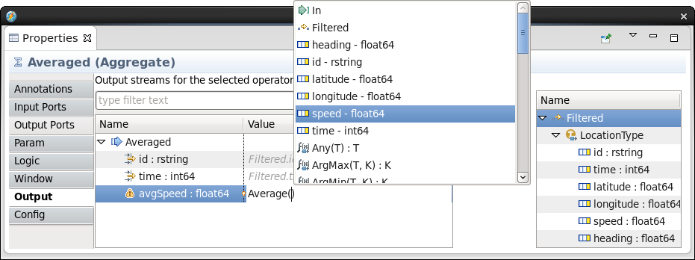

|  |  |
| --- | --- |
| sign-info | Custom output functions  The functions shown in content assist are *custom output functions* specific to the Aggregate operator. They are not general-purpose SPL functions. Every output assignment must contain a call to one of these. The automatic assignments for the non-numeric attributes described above implicitly call the **Last(T)** custom output function. |

1. Specify where the results go: select the newly added **FileSink** operator (**AvgWriter**).
   1. In the **Param** tab, set the **file** parameter to "average.speeds" (with the double quotes).
   2. Click **Add…**; in the **Select parameters** dialog, check **format** and **quoteStrings**; click **OK**. Set **format** to csv and **quoteStrings** to false.
   3. Save. Close the **Properties** view. Your application is ready to launch.
2. Launch the application. Right-click **MyMainComposite** in the **Project Explorer** and choose **Launch…**. Click **Apply** (if necessary) and **Continue** in the **Edit Configuration** dialog.

## The Streams Console

The Streams Console is a general-purpose, web-based administration tool. Each Streams domain has its own console environment; the console interacts with one specific domain at a time, based on its *Streams Web Service* (SWS) URL. In addition to managing and monitoring instances, resources, jobs, logging and tracing, and many other administrative things, it serves as a simple data visualization tool. It is not intended to be a production-quality dashboard such as Cognos, but mainly a useful facility for monitoring applications and understanding data during development.

There are several ways to launch the Console: with a desktop launcher, or by looking up the URL and opening it directly in Firefox or any other browser—from any machine with https access to the Streams environment. Normal user authentication and security apply. You’ll open it from within Studio.

1. In the **Streams Explorer**, expand **Streams Domains**. Right-click on **StreamsDomain** (the only domain listed) and choose **Open Streams Console**.
   1. In the **Untrusted Connection** page, expand **I Understand the Risks** and click **Add Exception…**.
   2. In the **Add Security Exception** dialog, keep **Permanently store this exception** checked and click **Confirm Security Exception**.
   3. Log in with streamsadmin / passw0rd.

The initial view is the **Management Dashboard**, which monitors the domain from an administrator’s point of view. Each of the views, called *cards*, shows a specific type of object (PEs, jobs, instances, and so on), with a graphical view that lets you see at a glance what is going on. At the top is a navigation bar with buttons that show a count of objects and their state (healthy/unhealthy or stopped/starting/running) and let you get quickly to a monitoring view for that object.

Figure 4 below shows a snapshot highlighting some of the graphically depicted information. For example, the **PEs** card shows quickly which PEs consume little memory and CPU (in the bottom left) and which consume a lot (top and right). This lets a developer identify quickly which operators to focus on during performance optimization, or pinpoint a memory leak.

|  |  |
| --- | --- |
| sign-info | Remember PEs?  As described in step __2. on page 26, a PE or Processing Element is essentially a runtime process, encapsulating one or more operators. Where the operator is the logical unit of operation, the PE is the unit of execution at runtime. |

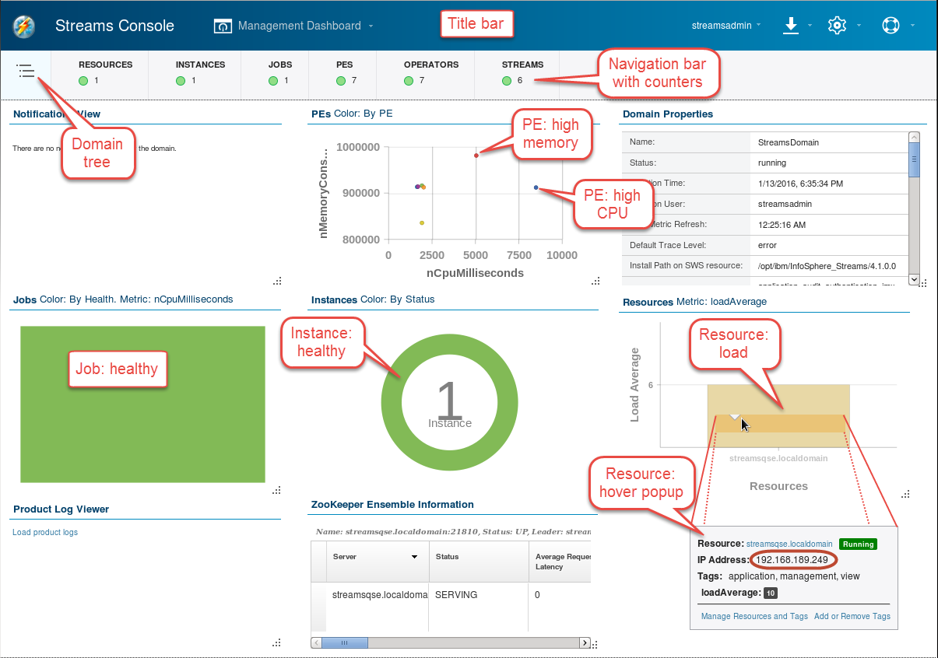

Figure . Monitoring the domain in the Management Dashboard

With only a single job running in a single instance on a single resource, many of the graphics are not very interesting, but they are extremely useful when managing a real cluster with many running jobs. Hovering over the graphic in each card pops up a panel with detailed information and links for drilling down further. Also while hovering, controls appear in the top right of the card:  
**Card Settings** (color schemes, filters, and other settings appropriate for the information shown), **Refresh**, **Card Flip Action** (to show the tabular data behind a graphic), **Stack** (minimize the card), and **Max** (maximize the card). Not all cards have all controls.

1. Explore the dashboard: resize, rearrange, and maximize cards; flip a card (for example, **PE Details**) to see the information in tabular form. Hover over one of the categories in the navigation bar and in the popup click on Monitor [Instance | Job | …] to see a different set of cards.

|  |  |
| --- | --- |
| sign-info | Browser acting slow?  The Console uses fancy graphics, which likely makes the browser the heaviest CPU consumer in your VMware environment (the “guest”), crowding out the Streams runtime and application. If the Console responds slowly or occasionally freezes up, try using a browser in the native environment of your computer (the “host”). Depending on your configuration, this may let the browser run on different CPU cores, freeing up the cores used by the guest for Streams itself.  Copy the URL: [https://*streamsqse.localdomain*:8443/streams/domain/console](https://streamsqse.localdomain:8443/streams/domain/console) from the address bar of the guest browser. Paste it into the address bar of the host browser, and replace the hostname streamsqse.localdomain with the IP address, which you get from the hover popup of the Resources card (see Figure 4 on page 36). Close the guest browser when you connect successfully. |

## The application dashboard

Let’s look closer at your running application. As a developer, you would be interested in the Application Dashboard; you can even set up your own dashboard by saving a set of cards in your preferred arrangement, with a query to focus on just the jobs that are of interest to you.

1. In the title bar, choose **Management Dashboard > Open Dashboard > Application Dashboard**.

See Figure 5 on page 38. Some of the cards are equivalent to similar ones in the Management Dashboard: **PE Metrics Scatter Chart** shows the same information as **PEs** (but with the axes swapped); **Resource Load Chart** is the same as **Resources**. In addition there is a **Summary** card that shows at a glance the health or exception status of jobs, operators, streams, and congestion (and consistent regions, which this lab does not explore); a **Streams Tree** that is a lot like the Streams Explorer in Studio; a **Streams Graph**, similar to the Instance Graph in Studio (if you have more than one job running, you’ll have to expand twisties to see their graphs); and a **Flow Rate Chart** showing the tuple submission rates of all source operators from all jobs.

The **Flow Rate Chart** is interesting. It shows that the tuple rate is bursty: the source operator (FileSource, in this case) reads the file as fast as it can, until it runs out of data; this fills up the input port buffer of the Throttle, which calmly draws down that buffer at 40 tuples per second. At just about the right time, when the Throttle is almost out of data, the same file is reported to the FileSource, which reads it again in one sharp burst. The chart shows the flow rate at zero most of the time, with peaks up to just over 600 tuples per second spaced 45 seconds apart. Note that the chart shows a moving average over three seconds; in reality, the FileSource reads the entire file (1902 tuples) in less than a second.

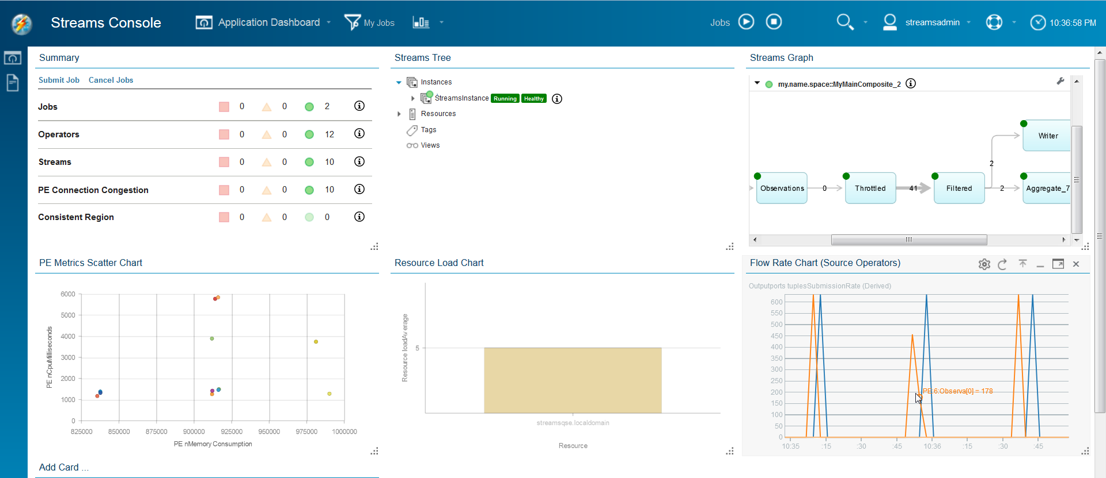

Figure Monitoring jobs in the Application Dashboard

## Optional: watching back-pressure develop

|  |  |
| --- | --- |
| sign-caution | This section is optional  It requires letting the job run for over a half hour and then observing the Console. In instructor-led settings, there is no time for this, but if you’re doing this lab on your own, you can choose to take a break, or come back to this section after completing the rest. |

1. Let the job or jobs run for at least 40 minutes.
2. Because the file is read every 45 seconds and the throttled drawdown takes a little longer than that (47.55 s), the Throttle’s input buffer eventually fills up. If you let the job(s) run long enough, a red square or yellow triangle will show up in the **PE Connection Congestion** row of the **Summary** card. (The congestion metric for a stream tells you how full the destination buffer is, expressed as a percentage.) At the same time, the **Flow Rate Chart** shows more frequent, lower peaks: the bursts are now limited by the filling up of the Throttle’s input buffer instead of by the data available in the file.
3. Hover over the  information tool in the **PE Connection Congestion** row in the **Summary** card to find out exactly which PEs are congested and how badly. Also notice how pattern in the Flow Rate Chart is now different compared to when the job was young.

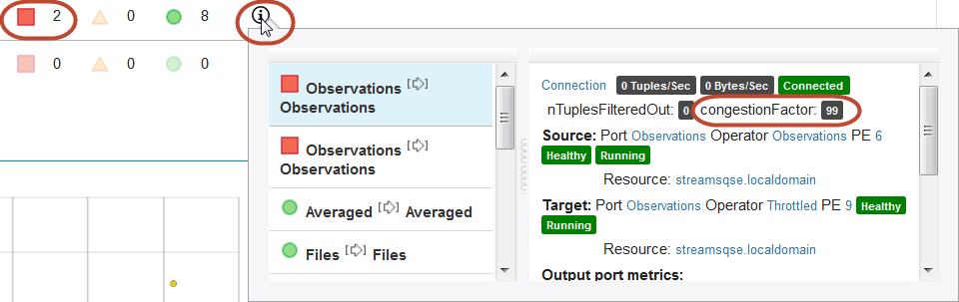 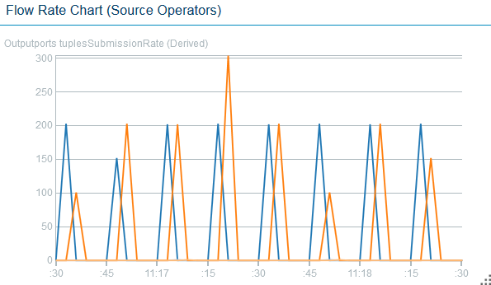

1. The information panel shows  at the top of the list: this means that congestion is observed on a stream called **Observations** at the output port of an operator of the same name (you did that by removing the operator alias). Note, however, that while **Observations** is the one that *suffers* congestion, it is the next operator, called **Throttled**, that *causes* it.
2. What will happen eventually, as you let this run for a long time? Will the FileSource operator continue to read the entire file every 45 seconds? What happens to its input buffer, on the port receiving the file names? How will the DirectoryScan operator respond?
3. These questions are intended to get you thinking about a phenomenon called *back-pressure*. This is an important concept in stream processing. As long as buffers can even out the peaks and valleys in tuple flow rates, everything will continue to run smoothly. But if buffers fill up and are never fully drained, the congestion moves to the front of the graph and something has to give: unless you can control and slow down the source (as conveniently happens here), data will be lost. There is no getting around that.

## Monitoring a job

1. Maximize the **Streams Graph** card. You can also enlarge it, using the resize handle  at the bottom right of the card, just enough to show the entire graph. Move it to another position and remove other cards as you see fit.

The graph is familiar from the **Instance Graph** in Studio, though it represents information in slightly different ways. It labels every stream with the tuple rate, and indicates operator health by a colored dot. As in the Instance Graph, relative tuple rate sets the thickness of the arrow. Usually the **Throttled** stream, at 40 tuples per second (give or take a few), is the thickest, but every so often the **Observations** stream, normally at zero, exceeds it. You observed the same behavior in the **Flow Rate Chart**.

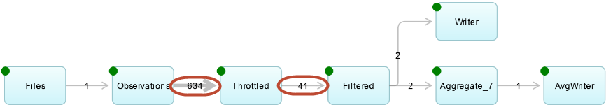

The **Streams Graph** is an alternative to the **Summary** card to detect trouble (unhealthy PEs), and to identify bottlenecks that may affect throughput performance. A bottleneck is an operator that limits the flow of tuples, usually because it cannot process any more tuples per second with the CPU cycles it has. If you did the optional section 3.5, above, you will have seen the **Throttle** operator be the cause of congestion that builds up over time.

|  |  |
| --- | --- |
| sign-info | An artificial bottleneck  In most “real” applications, there is no place for a Throttle operator; you only used it here to simulate a data source with a manageable flow rate. Here, it also serves as a useful illustration of the concept of back pressure, and of the tools for identifying real bottlenecks. |

Even if congestion has not yet built up, a good indicator of a candidate for a bottleneck is a PE that consumes lots of CPU cycles: it would be toward the top in the **PE Metrics Scatter Chart**.

1. Hover over the topmost point(s) in the **PE Metrics Scatter Chart** (highest in CPU consumption).
2. Chances are, the operator is called **Throttled**. Apparently, the Throttle operator consumes CPU cycles to slow down the flow, while all the others are reading and writing files, or filtering and aggregating tuples, at very low CPU cost.

Of course, as long as the PE keeps up with the tuple flow, high CPU load doesn’t necessarily mean bottleneck. In this case, it is not apparent until the job has run for a long time that the **Throttle** operator is indeed a bottleneck.

## Visualizing data

Data is carried in tuples; tuples flow on streams. To view data, you have to monitor a stream.

1. In the **Streams graph**, hover over the **Filtered** stream (from Filtered to Averaged). In the panel that pops up, click **Create View**.
2. 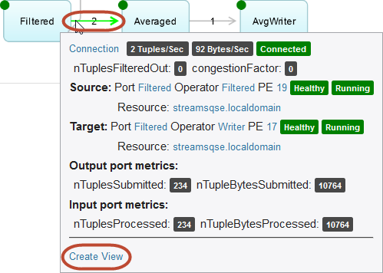
3. **Data Visualization** **Views** are comparable to the **Show Data** views in Studio.
   1. In the **Basics** tab, change the **View Name** to something more descriptive: for example, Filtered cars. Edit the **View Description** if you like, but this is not important.
   2. In the **Buffer** tab, set the **Tuples/sec Throttle** to **5**. Because each car reports about once per second and the Filtered stream only represents two cars, this should allow the view to keep up with all selected tuples without throttling (subsampling).
   3. In **Buffer Size Configuration**, keep the **Limit By** option of **Tuple Count** and set it to **50**.
   4. Explore the table. The whole table contains 50 rows. Click **50** at the bottom of the card to make a single page. Click the **id** column header to sort by id and scroll up and down to see a short history of each car. Click the **time** column header (the last one, not the first column **Time**, which is not an attribute but a column generated by the view) **twice** to see the latest tuples at the top. Resize columns and card as needed.
   5. 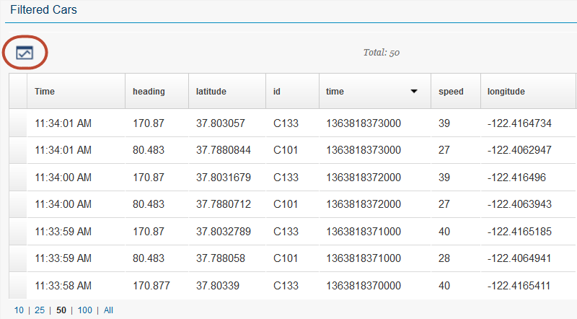
4. It’s easier to interpret numerical data when you depict it graphically. Let’s look at speed and heading. Since they have different numeric ranges, it’s best to show them in separate charts. Speed first.
   1. In the data visualization view, click  **Create Chart**.
   2. In the **Chart** tab of the **Create Time Series Line Chart** dialog, adjust the **Chart name** as you see fit; for example, “Filtered Cars: Speed”.
   3. In the **Categories** tab,
      1. select **Values of One Attribute:**
      2. set **Measured by (Y-Axis)** to **speed**
      3. set **Plot Lines With Values Of:** to **id**
      4. keep **All Values** selected.
5. Next, heading. Perform the same steps as in step __3. above but choose **heading** in **Measured by**, and set an appropriate Chart name.
6. To create a comparative view of the effect of the aggregation analytic you added to the application in this part, create a data visualization view of the **Averaged** stream and create a chart showing the average speed for both cars. Use instructions __1. through __3. above, with appropriate substitutions for stream and attribute names.

You now can gain more insight in your data by inspecting it visually. For example, it becomes clear that the heading makes big jumps between relatively constant periods; this makes sense in an American city, where most turns are 90 degrees. Also, the speed, while in principle a measured quantity best represented by a floating-point number, is only reported as whole numbers (this is also obvious from the table view), lending a stair-step quality to the plot; this may mean that some efficiency can be gained by changing the attribute type to int32 or even int16 or int8—provided that it can be verified that no source will ever have non-integer speed values.

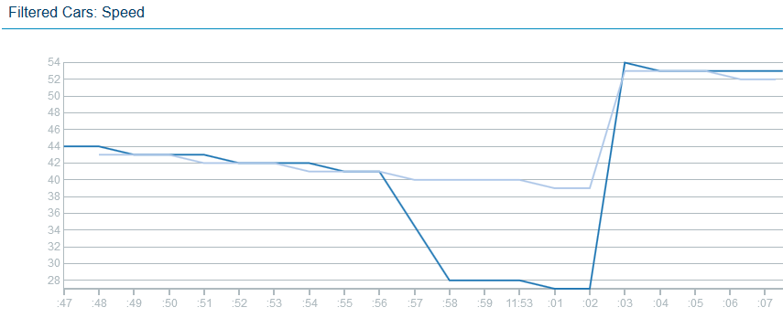

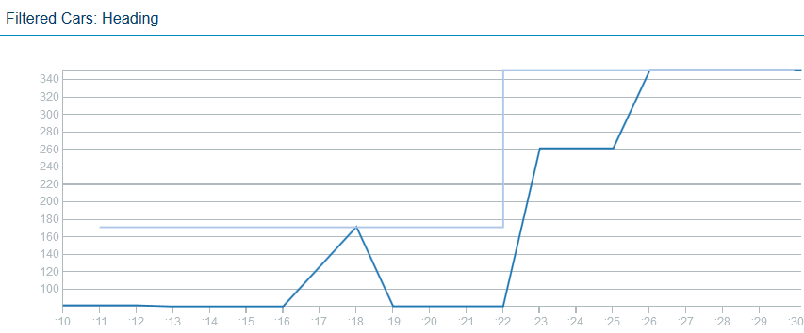

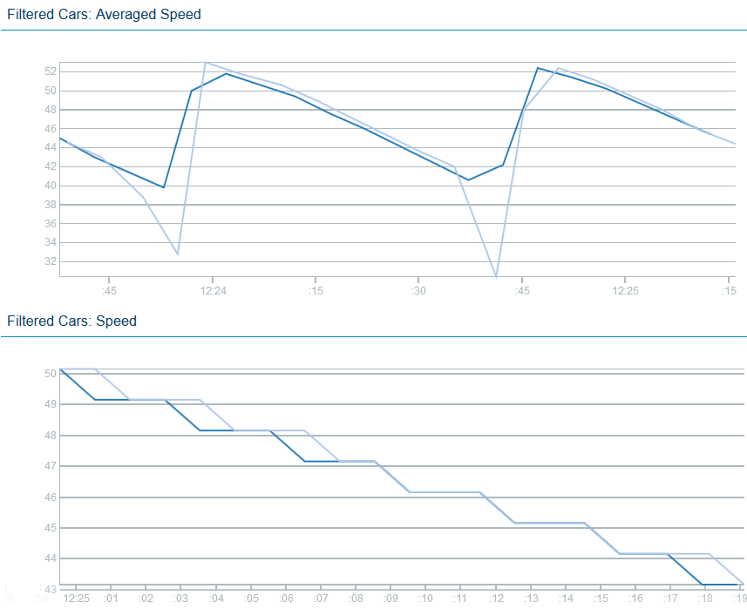

When you are ready to move on to the next part, close or minimize the browser and get back into Studio.

# Modular application design with exported streams

## Building on the previous results

|  |  |
| --- | --- |
| sign-caution | This section is optional  If you are confident that your results from the previous part are correct, you can continue working with them and skip this section. |

To continue with this part even if you did not successfully complete the previous part, import a Streams project that has been prepared for you, containing the expected results of Part 3.

1. In the Project Explorer, right-click on the current project (MyProject) and choose **Close Project**.
2. This gets it out of the way for builds or name conflicts, without deleting any files.
3. In the top Eclipse menu, choose **File > Import…**.
4. In the Import dialog, select **InfoSphere Streams Studio > SPL Project**; click **Next >**.
5. Click **Browse…**; in the file browser, expand **My Home**, scroll down, and select **Labs**. Click **OK**.
6. Select (check the box) **MyProject3** and click **Finish**.
7. This kicks off a build, but there is no need to wait until it finishes.
8. In the Project Explorer, expand **MyProject3** and then **my.name.space**.
9. Double-click **MyMainComposite** to open it in the graphical editor.
10. In the editor palette, right-click on **Toolkits**; in the context menu, uncheck **Show All Toolkits**.

## Adding a test for unexpected data

It is generally good practice to validate the data you receive from a feed. Data formats may not be well defined, ill-formed data does occur, and transmission noise can creep in as well. You do not want your application to fail when the data does not conform to its expectations. In this part, you will be receiving live data; who knows what it will do to your analytical process?

As an example of this kind of validation, you will add an operator that checks one attribute, the vehicle ID (**id**). In the data file all.cars, all records have an id value of the form “C*nnn*” (presumably, with “C” for “car”). Even though it doesn’t at the moment, assume that your application depends on this format; for example, it could take a different action depending on the type of vehicle indicated by that first letter (say, “B” for “bus”); and there may be a system requirement that all vehicle IDs be exactly four characters long. Rather than silently dropping the tuple, however, it is better practice to save the “bad” data so you can audit what happened and later perhaps enhance the application.

In summary, the specifications are as follows:

Table . Vehicle ID (id attribute) specifications

|  |  |
| --- | --- |
| **Criterion** | **Value** |
| **First character** | **“C”** |
| **Length** | **4** |

In other words, if any data comes in with an unexpected value for **id**, your program will shunt it aside as invalid data. There are several operators that can take care of this; which one you use is to some degree a matter of taste. You have already used one that fits the bill, the **Filter**. So let’s use a different one here.

The **Split** operator is designed to send tuples to different output ports (or none) depending on the evaluation of an arbitrary expression; this expression can, but does not have to, involve attribute values from the incoming tuple. It can have as many output ports as you need. In this case you only need two: one for the regular flow that you’ve been dealing with (the “valid” values), and one for the rest (the “not valid” ones).

The **Split** mechanism works as follows (see the example in Figure 6, below);

* The N output ports are numbered 0, 1, …, N-1.
* A parameter called **index** contains an arbitrary expression that returns a 64-bit integer   
  (an **int64** or a, if unsigned, a **uint64**).
* This expression is evaluated for each incoming tuple.
* The expression’s value, *n*, determines which output port *p* the tuple is submitted to:
  + If *n* ≥ 0, *p* = *n* modulo N
  + If *n* < 0, the tuple is dropped

1. 

Figure . A Split operator with three output ports.

|  |  |
| --- | --- |
| sign-info | Remember  At any time during the steps below, use  **Layout** and  **Fit to Content** to keep the graph organized and visible. |

1. Add a **Split** operator to the graph. In this case, you need one with two output ports.
   1. In the graphical editor, find the **Split** operator, either by using the **Find** box or browsing down to **Toolkits > spl > spl.utility > Split**.
   2. Drag a Split operator (not a template) into the canvas and drop it directly onto the **Throttled** stream (output of the Throttled operator).
   3. Drag an **Output Port** from the palette (under **Design**) onto the Split operator. This gives it a second output port.
2. Capture the Split’s second output stream in a file.
   1. Add a **FileSink** to the graph.
   2. Drag a **stream** from the second output of the **Split** to the input of the new **FileSink**.
   3. Drag the **LocationType** schema from the palette (under **Current Graph**/**Schemas**) onto the new stream. This turns it from dashed to solid.
3. Notice that the new stream from the Split’s first output port is already solid: it automatically inherits the schema from the original Throttled stream.
4. Edit the properties of each of the new streams; in the **General** tab, rename the first stream (the one that goes to **Filtered**) to Expected; rename the second to Unexpected.
5. 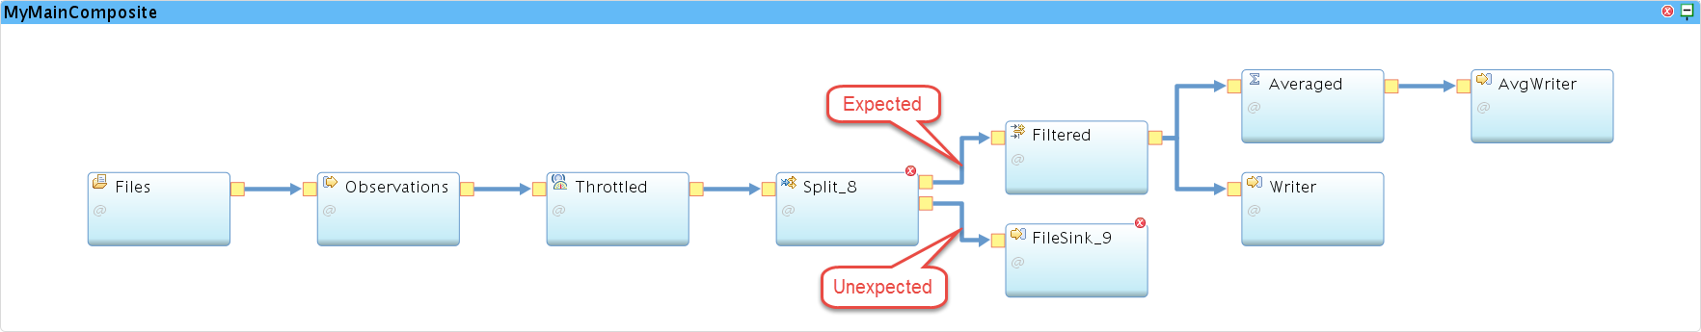
6. Configure the **Split** operator. Because it has two output streams, it is better to set a descriptive alias than to blank it out; otherwise, it would be known by the name of the first output stream (Expected), which is somewhat misleading.
   1. Edit the operator properties. In the **General** tab, **Rename** it to IDChecker.
   2. In the **Param** tab, click **Add…**; check **index** and click **OK**.
   3. In the **Value** field for the **index** parameter, type the following **exactly** (NOTE: the "l" after 0 and 1 is a lowercase letter ell, to indicate a “long”, 64-bit integer):  
       substring(id,0,1) == "C" && length(id) == 4 ? 0l : 1l
   4. How to read this? “If the substring of the id attribute starting at offset zero with length one (in other words, the first character of id) is ‘C’ and the length of the id attribute is four, then zero; otherwise one.” So, proper IDs go out from the first port (**Expected**), and everything else goes out from the second port, **Unexpected**.
   5. 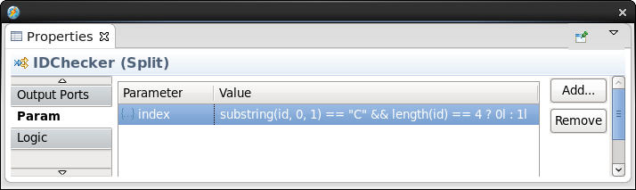

|  |  |
| --- | --- |
| sign-info | SPL expression language syntax  The syntax <boolean-expression> **?** <action-if-true> **:** <action-if-false>  is known from C, Java, and other languages. The functions substring(string,start,length) and length(string) are from the Standard Toolkit. The suffix “l” (the letter ell) indicates that the numbers are 64-bit values (“long” integers). SPL does not make implicit type conversions; integer numbers with no suffix are 32-bit values, and assigning one to a 64-bit parameter would raise an error. |

1. Configure the new **FileSink** operator. You’ve used a FileSink in two previous parts, so refer back to those if you forgot how to do it.
   1. First **Rename** it to ErrWriter.
   2. Set the following parameter values:

Table . Parameter values for ErrWriter. Note the extra parameter flush.

|  |  |
| --- | --- |
| Parameter | Value |
| **file** | "error.observations" |
| **flush** | 2u |
| **format** | csv |
| **quoteStrings** | false |

|  |  |
| --- | --- |
| sign-info | Flushing buffered file writes  FileSink performs buffered file I/O, meaning that it writes to buffers maintained by system libraries rather than directly to disk. These buffers are only written out to disk (*flushed*) as they fill up, or when the requesting application terminates. When the output is a slow trickle, this can mean that you will not see anything in the file for a long time. Setting flush to 2u (the u is for “unsigned” integer) guarantees that you will see data at least in batches of two records. |

1. Save, launch the app, and verify that the original output files, **filtered.cars** and **average.speeds**, are being written to the data directory as before, and that the new output file (**error.observations**) has at least two records in it, after a suitable amount of time: the input file contains two records with a malformed ID (and other abnormal attribute values as well).

## Splitting off the ingest module

Now it gets interesting. Within a Streams application, data flows from operator to operator on **streams**, which are fast and flexible transport links. The Streams application developer is not concerned with how these are implemented. They may work differently between operators running on different hosts, in different PEs on the same host, or within the same PE, but the logic of the graph stays the same. When an application needs to exchange data with the outside world, that requires the explicit use of **source** and **sink** operators—for file I/O, ODBC, TCP, UDP, or HTTP connections, message queues, and so on.

For Streams applications running in the same instance, however, another mode of data exchange is possible: **Export** and **Import**. An application can export a stream, making it available to other applications running in the instance; one or more applications can import such a stream, based on flexible criteria. Exported streams, once they are connected, are just like all the other streams that run between PEs within an application—fast and flexible. It’s only at the time a job is submitted or canceled that the runtime services get involved to see which links need to be made or broken; once that’s done, there is no difference in runtime behavior (well, almost none, but the difference is beyond the scope of this lab), and there is no performance penalty.

But there is a tremendous gain in flexibility. Application stream connections can be made based on publish-and-subscribe criteria, and this allows developers to design completely modular solutions, where one module can evolve and be replaced, removed, or replicated, without affecting the other modules. It keeps individual modules small and specialized.

In the lab so far, you have built a monolithic app, but there is a logical division. The front end of the app, from DirectoryScan to Throttle, is concerned with reading data, in this case from files, and “replaying” that data in a controlled fashion to make it look like a real-time feed. The rest of the app, from Split to FileSinks, performs analysis and writes out the results. If you split off the front end into a separate “Ingest” module, you can imagine that it would become easy to have another module, alongside it or as a replacement, that produces tuples that have the same structure and similar contents, but that come from a completely different source. And that is exactly what this part will do: add another module that reads a live data feed and makes the data available for processing by the rest of this application.

1. In the graphical editor, drag a **Composite** (under **Design** in the palette) and drop it on the canvas. Not on the existing main composite, but outside of any graphical object. The editor will call it Composite; rename it to **FileIngest**.

Notice that the new composite appears in the Project Explorer, but it does not have a build associated with it. Create one.

1. In the **Project Explorer**, right-click the **FileIngest** main composite. Choose **New > Distributed Build**. In the dialog that pops up, change the **Configuration name** to Distributed, accept all other defaults, and click **OK**.
2. Move the three front-end operators from the old main composite to the new.
   1. In **MyMainComposite**, select the three operators **Files**, **Observations**, and **Throttled**.
   2. To do this, hold down the **Ctrl-key** while clicking each one in turn. Cut them (**Ctrl+X** or right-click, **Cut**) to the clipboard.
   3. Select the FileIngest composite; paste the three operators in (**Ctrl+V** or right-click, **Paste**).

You now have two applications (main composites) in the same code module (SPL file). This is not standard practice, but it does work. The applications, however, are not complete: you have broken the link between **Throttled** and **IDChecker**.

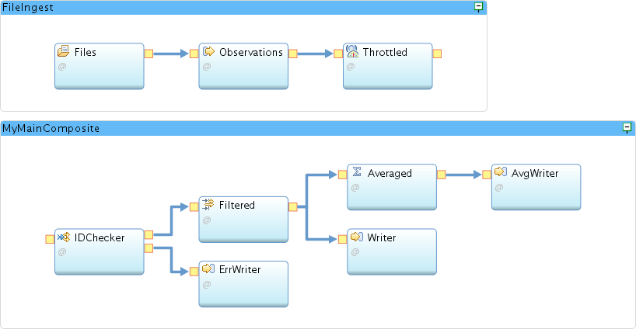

1. Set up the new application (**FileIngest**) for stream export.
   1. In the palette, find the **Export** operator and drop one into the **FileIngest** composite.
   2. Drag a stream from **Throttled** to the **Export** operator. Note that the schema is remembered even while there was no stream, since it belongs to the output port of **Throttled**.
   3. Edit the **Export** operator’s properties; **Rename** it to FileExporter.
   4. In the **Param** tab, add the **properties** parameter. In the **Value** field for **properties**, enter the following “tuple literal”:  
      { category = "vehicle positions", feed = "sample file" }
   5. 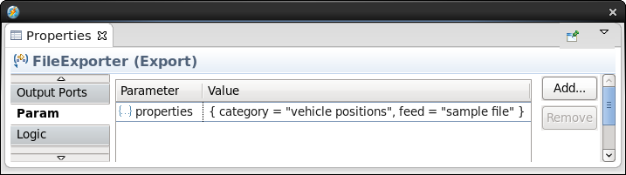

What this does is “publish” the stream with a set of properties that are completely arbitrary pairs of names and values. The idea is that an importing application can look for streams that satisfy a certain *subscription*: a set of properties that need to match.

* 1. Save. The **FileIngest** application builds, but **MyMainComposite** still has errors.

1. Set up the original application for stream import.
   1. In the palette, find the **Import** operator and drop it into the old main composite.
   2. Drag a stream from **Import_11** to **IDChecker**.
   3. Assign a schema to this stream, by dragging and dropping **LocationType** from the palette.
   4. **Rename** the new stream to Observations. (There is already another stream called Observations, but it is now in a different main composite, so there is no name collision.)
   5. Select the **Import** operator and **Rename** it to Observations by blanking out the alias.
   6. In the **Param** tab, edit the Value for parameter **subscription**. Replace the placeholder parameterValue with the following boolean expression:  
       category == "vehicle positions"
   7. 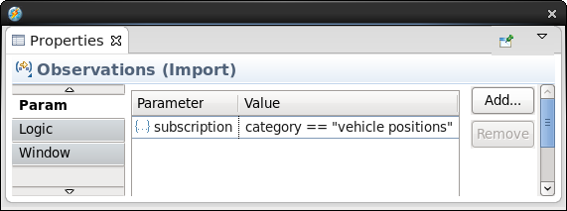
2. Notice that this is only looking for one property: the key category and the value "vehicle positions". It is perfectly fine to ignore the other one that happens to be available; if the subscription predicate is satisfied, the connection is made (as long as the stream types match).
   1. **Save**.
3. Test the new arrangement of two collaborating applications.
   1. In the **Instance Graph**, cancel any remaining jobs. Set the color scheme to **Flow Under 100 [nTuples/s]**. Enlarge the view so you can comfortably see the two jobs.
   2. In the Project Explorer, launch the old application, **MyMainComposite**.
   3. Launch the new application **FileIngest**.

Notice that the tuples flow from operator to operator throughout the instance graph, even though they are divided into two main composites. Leave the two applications running; you’ll be adding a third.

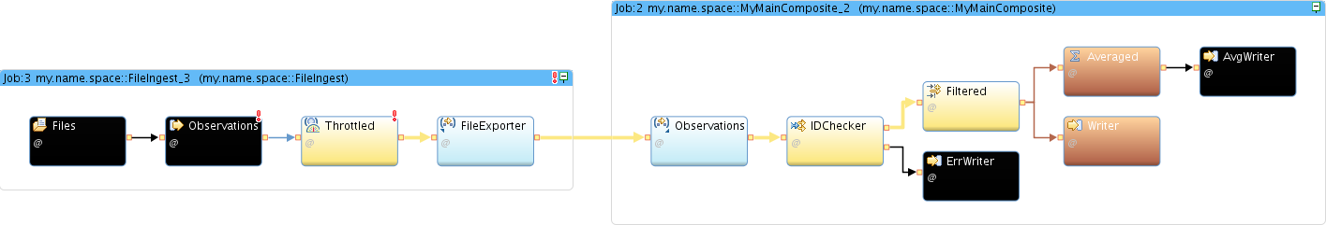

## Adding a live feed

|  |  |
| --- | --- |
| sign-caution | Note  This section assumes that you have internet connectivity. If your lab environment is not connected, you can still go through the steps of importing and launching the application and seeing the connections being made, but no live data will flow. In most cases, there will be no other symptoms.  In instructor-led events in venues where participants’ machines have no connectivity, the instructor may go through this section as a demonstration rather than an exercise for everyone to complete. |

Rather than building a live-data ingest application from scratch, you will i**mport a Streams project** that has already been prepared. This application uses an operator called **HTTPGetXMLContent**, from a version of the **com.ibm.streamsx.inet Toolkit** that can currently only be found on GitHub, to connect to a web servicesfeed from **NextBus.com** and periodically (every 30 seconds) download the current locations, speeds, and headings of San Francisco Muni’s buses and trams. It parses, filters, and transforms the data and makes the result look similar to the file data—though some differences remain. It exports the resulting stream with a set of properties that match the subscription of your processing app; when you launch the **NextBus** app, the connection is automatically made and data flows continuously until you cancel the job.

1. Before you can use the NextBus project, you must tell Studio where to find the version of the com.ibm.streamsx.inet toolkit that it depends on.
   1. In the **Streams Explorer**, expand **InfoSphere Streams Installations [4.1.0.0] > InfoSphere Streams 4.1.0.0 > Toolkit Locations**.
   2. Right-click **Toolkit Locations** and choose **Add Toolkit Location…**.
   3. In the **Add toolkit location** dialog, click **Directory…** and browse to **My Home > Toolkits**. (My Home is all the way at the top; the dialog comes up in the completely separate Root tree.) Select **Toolkits** and click **OK**.
   4. Click **OK** again.
2. If you expand the new location, **(Local) /home/streamsadmin/Toolkits**, you see **com.ibm.streamsx.inet[2.5.0]**. This is different from the version of this toolkit that is installed with Streams (2.0.1), so the NextBus project can select the right one by version. (You’ll find the 2.0.1 version under the location STREAMS_SPLPATH.)
3. Import the NextBus project.
   1. In the top Eclipse menu, choose **File > Import…**.
   2. In the Import dialog, select **InfoSphere Streams Studio > SPL Project**; click **Next >**.
   3. Click **Browse…**; in the file browser, expand **My Home** and select **Toolkits**. Click **OK**.
   4. Select **NextBus** and click **Finish**.
   5. 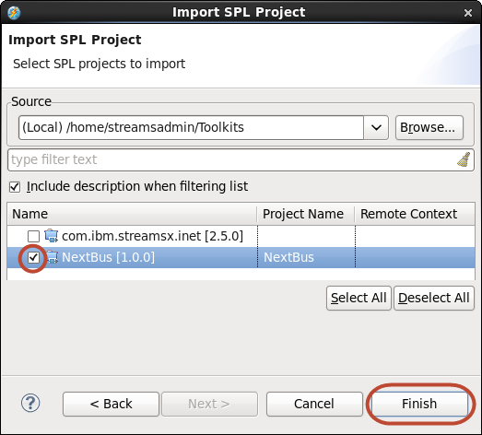
4. Expand project **NextBus** and namespace **com.ibm.streamslab.transportation.nextbus**. Launch application **NextBusIngest** (you may have to wait till the project build finishes).
5. Maximize and organize the Instance Graph. If you want, you can expand the nested composites in the NextBusIngest job.

You should see the three applications all connected; tuples flow from the **FileIngest** job whenever you copy another file into the **Data** directory. Tuples flow from the **NextBus** job in 30-second bursts. The **error.observations** file gradually fills with records from **NextBus**: their vehicle IDs do not conform to the “C*nnn*” format. (Refresh the file periodically: click in the editor showing the file and click **Yes** in the **File Changed** dialog, which comes up when Studio detects that the underlying contents have changed.)

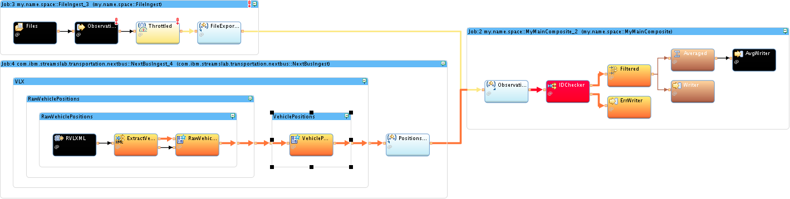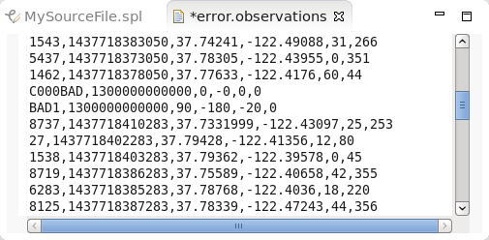

## Showing location data on the map

The NextBus toolkit comes with another application that lets you view data in a way that is more natural for data that involves locations: on a map. Just like MyApplication, it is designed to connect to the kind of stream exported by NextBusIngest and FileIngest. Without any further configuration, it can take the latitude and longitude values in the tuples, along with an ID attribute, and generate an appropriate map.[1] It is not the prettiest or most dynamic of maps, but real cartography is a lot of work, and this is only intended as a quick method for learning about your data—similar to the views and charts in the Streams Console.

1. In the NextBus toolkit, launch **NextBusVisualize**. In the **Edit Configuration** dialog, scroll down to see the **Submission Time Values**; note the value of the **port** variable: **8080** (widen the Name column to see the full name).

In the Instance Graph, each of the two exported streams is connected to each of the downstream jobs. The arrows look a bit confusing, but if you select each of the branches in turn, you can untangle them.



1. To open the map in the Firefox browser, double-click the **Live Map** desktop launcher.   
   (Minimize the Studio window or move it out of the way to see it.)
2. You will see a map of the San Francisco Bay Area, with a large number of green markers crowding the city of San Francisco. Use the map controls or mouse wheel to **zoom in** and pan (hold down the left mouse button to drag and center the map), so you can see the individual vehicles. They jump around as their locations are updated: the map is live!
3. The map refreshes every second, but remember that NextBus data is only updated every 30 seconds. If you zoom in far enough (click the  zoom tool five times from the starting level), you can see the simulated cars from the file move continually around downtown San Francisco. (They jump periodically, as the locations start over at the top of the file.)
4. Hover over or click any one of the markers to get the full list of attributes for that vehicle.

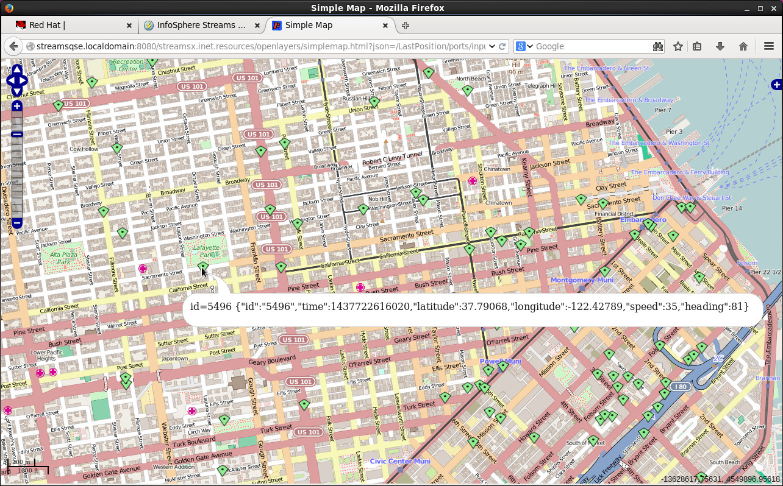

|  |  |
| --- | --- |
| sign-caution | If you did not finish or your app is not working  Import the finished project from the installed lab files. For instructions, see **4.1 Building on the previous results** on page 43, but import **MyProject4** instead of MyProject3. |

## Putting it all together

This lab has barely scratched the surface of what Streams is capable of. Apart from a very small number of SPL expressions, no coding was involved in building a progressively more interesting application. Ultimately, with the help of a prepared but still simple additional module, this set of applications is able to handle a continuous flow of live vehicle location observations, and distinguish between different kinds of content. Simply by using a few building blocks, sketching a graph that governs how the tuples flow, and setting some parameters in a property view, the beginnings of a reasonably powerful solution have taken shape.

Your next steps are to decide whether this application development platform for streaming data can help you build solutions that enhance your business; whether what you have seen gives you a sense that it can help solve problems you already have in mind; and whether your organization has access to the required development skills or should invest in building them. IBM provides formal training courses for this product, and our technical sales specialists can help identify opportunities for streaming data-based solutions, organize workshops, and move to pilot projects and beyond.

**HAPPY STREAMING**

1. Maps from OpenStreetMap (http://www.openstreetmap.org), via OpenLayers (<http://openlayers.org>).